

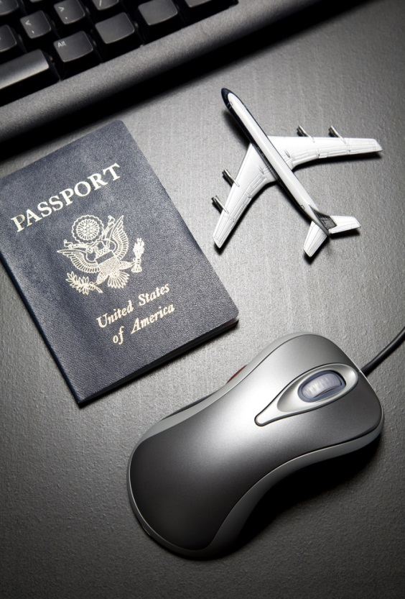

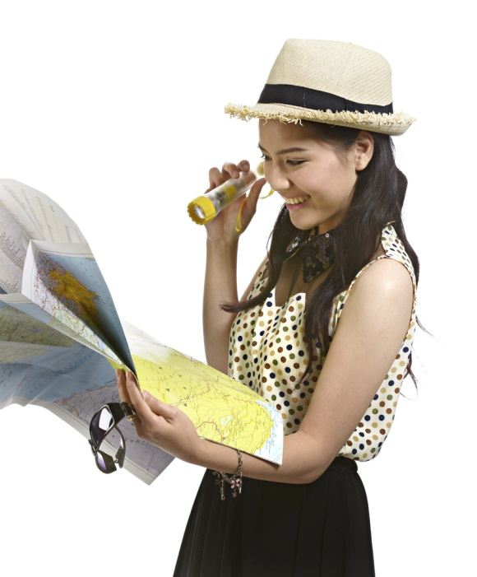




Work as a tour guide
D2.TTG.CL3.01
Trainee Manual

Work as a tour guide
D2.TTG.CL3.01
Trainee Manual





Project Base
William Angliss Institute of TAFE
555 La Trobe Street
Melbourne 3000 Victoria
Telephone: | (03) 9606 2111
Facsimile: | (03) 9670 1330
Acknowledgements
Project Director: | Wayne Crosbie
Project Manager | Jim Irwin
Chief Writer: | Alan Hickman with thanks to Penny Irons
Subject Writer: | Alan Hickman
Editor: | Jim Irwin
DTP/Production: | Daniel Chee, Mai Vu, Cindy Curran

The Association of Southeast Asian Nations (ASEAN) was established on 8 August 1967. The Member States of the Association are Brunei Darussalam, Cambodia, Indonesia, Lao PDR, Malaysia, Myanmar, Philippines, Singapore, Thailand and Viet Nam.
The ASEAN Secretariat is based in Jakarta, Indonesia.
General Information on ASEAN appears online at the ASEAN Website: www.asean.org.
All text is produced by William Angliss Institute of TAFE for the ASEAN Project on “Toolbox Development for Front Office, Food and Beverage Services and Food Production Divisions”.
This publication is supported by the Australian Government’s aid program through the ASEAN-Australia Development Cooperation Program Phase II (AADCP II).
Copyright: Association of Southeast Asian Nations (ASEAN) 2015.
All rights reserved.
Disclaimer
Every effort has been made to ensure that this publication is free from errors or omissions. However, you should conduct your own enquiries and seek professional advice before relying on any fact, statement or matter contained in this book. The ASEAN Secretariat and William Angliss Institute of TAFE are not responsible for any injury, loss or damage as a result of material included or omitted from this course. Information in this module is current at the time of publication. Time of publication is indicated in the date stamp at the bottom of each page.
Some images appearing in this resource have been purchased from stock photography suppliers Shutterstock and iStockphoto and other third party copyright owners and as such are non-transferable and non-exclusive. Clip arts, font images and illustrations used are from the Microsoft Office Clip Art and Media Library. Some images have been provided by and are the property of William Angliss Institute.
Additional images have been sourced from Flickr and SXC and are used under Creative Commons licence: http://creativecommons.org/licenses/by/2.0/deed.en

File name: TM_Work_as_a_tour_guide_290415





Table of contents
Introduction to trainee manual 1
Unit descriptor 3
Assessment matrix 5
Glossary 7
Element 1: Describe the context for the delivery of guiding services 9
Element 2: Develop guiding skills and knowledge 35
Element 3: Provide guiding services 47
Element 4: Communicate with industry personnel 81
Presentation of written work 89
Recommended reading 91
Trainee evaluation sheet 93
Trainee self-assessment checklist 95

Introduction to trainee manual

To the Trainee
Congratulations on joining this course. This Trainee Manual is one part of a ‘toolbox’ which is a resource provided to trainees, trainers and assessors to help you become competent in various areas of your work.
The ‘toolbox’ consists of three elements:
- A Trainee Manual for you to read and study at home or in class
- A Trainer Guide with Power Point slides to help your Trainer explain the content of the training material and provide class activities to help with practice
- An Assessment Manual which provides your Assessor with oral and written questions and other assessment tasks to establish whether or not you have achieved competency.
The first thing you may notice is that this training program and the information you find in the Trainee Manual seems different to the textbooks you have used previously. This is because the method of instruction and examination is different. The method used is called Competency based training (CBT) and Competency based assessment (CBA). CBT and CBA is the training and assessment system chosen by ASEAN (Association of South-East Asian Nations) to train people to work in the tourism and hospitality industry throughout all the ASEAN member states.
What is the CBT and CBA system and why has it been adopted by ASEAN?
CBT is a way of training that concentrates on what a worker can do or is required to do at work. The aim is of the training is to enable trainees to perform tasks and duties at a standard expected by employers. CBT seeks to develop the skills, knowledge and attitudes (or recognise the ones the trainee already possesses) to achieve the required competency standard. ASEAN has adopted the CBT/CBA training system as it is able to produce the type of worker that industry is looking for and this therefore increases trainee chances of obtaining employment.
CBA involves collecting evidence and making a judgement of the extent to which a worker can perform his/her duties at the required competency standard. Where a trainee can already demonstrate a degree of competency, either due to prior training or work experience, a process of ‘Recognition of Prior Learning’ (RPL) is available to trainees to recognise this. Please speak to your trainer about RPL if you think this applies to you.
What is a competency standard?
Competency standards are descriptions of the skills and knowledge required to perform a task or activity at the level of a required standard.
242 competency standards for the tourism and hospitality industries throughout the ASEAN region have been developed to cover all the knowledge, skills and attitudes required to work in the following occupational areas:
- Housekeeping
- Food Production
- Food and Beverage Service
- Front Office
- Travel Agencies
- Tour Operations.
All of these competency standards are available for you to look at. In fact you will find a summary of each one at the beginning of each Trainee Manual under the heading ‘Unit Descriptor’. The unit descriptor describes the content of the unit you will be studying in the Trainee Manual and provides a table of contents which are divided up into ‘Elements’ and ‘Performance Criteria”. An element is a description of one aspect of what has to be achieved in the workplace. The ‘Performance Criteria’ below each element details the level of performance that needs to be demonstrated to be declared competent.
There are other components of the competency standard:
- Unit Title: statement about what is to be done in the workplace
- Unit Number: unique number identifying the particular competency
- Nominal hours: number of classroom or practical hours usually needed to complete the competency. We call them ‘nominal’ hours because they can vary e.g. sometimes it will take an individual less time to complete a unit of competency because he/she has prior knowledge or work experience in that area.
The final heading you will see before you start reading the Trainee Manual is the ‘Assessment Matrix’. Competency based assessment requires trainees to be assessed in at least 2 – 3 different ways, one of which must be practical. This section outlines three ways assessment can be carried out and includes work projects, written questions and oral questions. The matrix is designed to show you which performance criteria will be assessed and how they will be assessed. Your trainer and/or assessor may also use other assessment methods including ‘Observation Checklist’ and ‘Third Party Statement’. An observation checklist is a way of recording how you perform at work and a third party statement is a statement by a supervisor or employer about the degree of competence they believe you have achieved. This can be based on observing your workplace performance, inspecting your work or gaining feedback from fellow workers.
Your trainer and/or assessor may use other methods to assess you such as:
- Journals
- Oral presentations
- Role plays
- Log books
- Group projects
- Practical demonstrations.
Remember your trainer is there to help you succeed and become competent. Please feel free to ask him or her for more explanation of what you have just read and of what is expected from you and best wishes for your future studies and future career in tourism and hospitality.

Unit descriptor
Work as a tour guide
This unit deals with the skills and knowledge required to Work as a tour guide in a range of settings within the tour industries workplace context.
Unit Code:
D2.TTG.CL3.01
Nominal Hours:
80

Element 1: Describe the context for the delivery of guiding services
Performance Criteria
1.1 Identify the roles, functions and responsibilities of a tour guide
1.2 List and differentiate between types of tour guides
1.3 Identify and differentiate between the groups a tour guide may lead
1.4 Describe the interpretive approach to tour guiding
1.5 Identify tour types
1.6 List the characteristics of a tour guide
1.7 Describe tour guiding principles

Element 2: Develop guiding skills and knowledge
Performance Criteria
2.1 Identify guide information sources and contacts
2.2 Acquire and up-date industry skills and knowledge
2.3 Identify legal, ethical and safety requirements that apply to provision of guiding services

Element 3: Provide guiding services
Performance Criteria
3.1 Demonstrate the skills and knowledge necessary to guide tours
3.2 Apply required legal, ethical and safety considerations to the conduct of tours
3.3 Optimise respect for local culture
3.4 Minimise negative impact on the culture, people and environment

Element 4: Communicate with industry personnel
Performance Criteria
4.1 Communicate with tourism industry operators
4.2 Communicate with colleagues

Assessment matrix
Showing mapping of Performance Criteria against Work Projects, Written Questions and Oral Questions
The Assessment Matrix indicates three of the most common assessment activities your Assessor may use to assess your understanding of the content of this manual and your performance - Work Projects, Written Questions and Oral Questions. It also indicates where you can find the subject content related to these assessment activities in the Trainee Manual (i.e. under which element or performance criteria). As explained in the Introduction, however, the assessors are free to choose which assessment activities are most suitable to best capture evidence of competency as they deem appropriate for individual students.
 |  |  | Work Projects | Written Questions | Oral Questions
Element 1: Describe the context for the delivery of guiding services
1.1 | Identify the roles, functions and responsibilities of a tour guide |  | 1.1 | 1 | 1, 2
1.2 | List and differentiate between types of tour guides |  | 1.1 | 2, 3, 4 | 3
1.3 | Identify and differentiate between the groups a tour guide may lead |  | 1.1 | 5 – 8 | 4
1.4 | Describe the interpretive approach to tour guiding |  | 1.1 | 9, 10 | 5
1.5 | Identify tour types |  | 1.1 | 11, 12 | 6
1.6 | List the characteristics of a tour guide |  | 1.1 | 13 | 7
1.7 | Describe tour guiding principles |  | 1.1 | 14 | 8
Element 2: Develop guiding skills and knowledge
2.1 |  | Identify guide information sources and contacts | 2.1 | 15 | 9, 10
2.2 |  | Acquire and up-date industry skills and knowledge | 2.1 | 16 | 11, 12, 13
2.3 |  | Identify legal, ethical and safety requirements that apply to provision of guiding services | 2.1 | 17, 18, 19 | 14, 15, 16
Element 3: Provide guiding services
3.1 | Demonstrate the skills and knowledge necessary to guide tours |  | 3.1 | 20 – 26 | 17, 18
3.2 | Apply required legal, ethical and safety considerations to the conduct of tours |  | 3.1 | 27 – 30 | 19
3.3 | Optimise respect for local culture |  | 3.1 | 31, 32, 33 | 20
3.4 | Minimise negative impact on the culture, people and environment |  | 3.1 | 34 | 21
Element 4: Communicate with industry personnel
4.1 |  | Communicate with tourism industry operators | 4.1 | 35, 36, 37 | 22
4.2 |  | Communicate with colleagues | 4.1 | 38, 39, 40 | 23

Glossary
Term | Explanation
DOB | Date of Birth
FIT | Fully independent tour
FIT | Fully Independent Traveller
Fam tours | Familiarisation tours
GIT | Group inclusive tour
Inclusions | Things ‘included’ in a tour – they may be side tours, merchandise, meals and/or refreshments, photographs, activities
Itinerary | A schedule for a tour showing what tour group members will be doing, where they will be going, and the times for each activity
Manifest | List of people on a tour together with other information as required by operator (tour group details, DOB of participants, contact person for each participant [NOK], ID provided)
Muster point | Location where tour group members meet
NOK | Next of Kin
Pax | Industry term for number of people/tour group members
Prop kit | Kit prepared by a tour guide containing props to assist with pre-prepared presentations throughout the tour at pre-determined times/sites
Q & A session | Question & Answer session
STG | Specialised Tourist Guide (Singapore)
Scripted commentary | A prepared talk about an identified topic/topics of interest to a tour group
Tour brief | A formal document provided by the employer to provide an overview and details of the tour
Tour Operators | Businesses who advertise, offer and conduct tours and who employ Tour Guides
Tour report | Document completed at the end of a tour providing required details of the tour as requested by the tour company/operator

Element 1: Describe the context for the delivery of guiding services

1.1 Identify the roles, functions and responsibilities of a tour guide

Introduction

The job of tour guide is a complex and demanding one.
This section looks at the various pre-requisite requirements necessary for delivering effective tour guide services.

Roles, functions and responsibilities
Being a Tour Guide/Tourist Guide requires attention to a wide range of roles, functions and responsibilities.
Tour Guides are often referred to as ‘the mortar that binds the tour together’.
In addition to any duties/requirements prescribed by individual employers, the following are accepted as being standard industry requirements.
Manager and leader
This is vital and central role because tourists/visitors and the employer expect the Tour Guide to take charge/control of the tour and tour group members.
This can involve:
- Managing the tour group members and leading the tour so:
- The schedule of the tour is adhered to
- No-one gets lost
- Behaviour is acceptable
- All participants get maximum value from the tour
- Issuing items as required for the tour – such as tickets, badges, equipment, handouts and other group-specific or tour-specific items
- Briefing people – on practical tour-related issues, and giving necessary operational and/or safety-related instructions
- Taking responsibility for the tour group – highlighting the need to:
- Ensure comfort of the group
- Guarantee their safety and security
- Respond to their individual needs/preferences
- Make sure visitors/tour group members enjoy their experience and ensure the tour lives up to advertisements/promises made about it and enhances the reputation and image of the Tour Operator and the destinations and host country
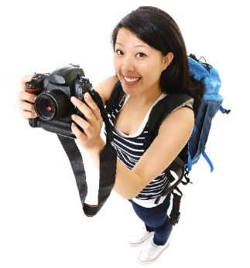
- Comply with all legal, moral and ethical requirements – including commonly accepted social standards/norms
- Monitor and supervise actions, language and interactions of the tour group
- Escorting tour group members to protect them and ensure their safety – this can mean taking charge and taking appropriate action when an emergency arises or when there is a need to take decisive action to accommodate unforeseen/unexpected circumstances
- Demonstrating confidence and credibility – by dressing appropriately, by acting and speaking professionally, by proving things are organised, by providing relevant and interesting information and insight into what is said
- Acting as a role model – about how tour group members should act/behave, about where they can go and cannot go, how to talk to others.
- Directing, navigating and moving people in relation to where they go, what they do, how long they spend in an area/on an activity
- Showing people what to do – such as demonstrating skills, demonstrating safety equipment/requirements, demonstrating local activities
- Path-finding – to show the way so people know where to go.
Mediator
This is needed in order to:
- Mediate problems and/or conflict within the group – or between individuals in the group
- Mediate issues between the tour and the place where the tour is being conducted – which may relate to issues such as:
- Timing of activities
- Access to exhibits/areas
- Duration of demonstrations
- Movement of groups
- Actions of individuals within the tour group.
Tourist Guides are often required to be the ‘social lubricant’ (regarded as a ‘social facilitator’) between members of a group to handle disputes and facilitate individual engagement with the tour (that is, to draw out those who appear alone, reluctant to participate or unhappy): high levels of social and interpersonal skills are essential for those who deliver tours.
All Tourist Guides must be a ‘people person’.
Communicator
This involves:
- Welcoming people to the tour – genuinely, warmly, personally and sincerely
- Delivering a commentary to tour group members – to explain, inform, illustrate and interpret the tour and to promote cultural awareness
- Responding to questions – asked by tour group members
- Providing information – about tour sites, locations, destinations, surrounding areas, products and services, events and festivals, history and culture, business, and (generally speaking) anything to do with the local area/country.
Being a good communicator also requires interpretation of aspects of the tour (such as culture and customs, history, the environment, social factors and the economy)
Cultural host
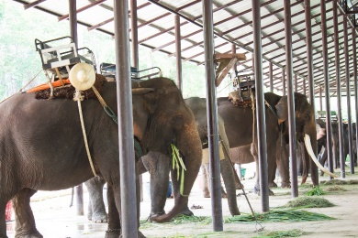
This relates to promoting and respecting local culture.
More on this is presented in section 3.3.
Teacher and mentor
All tours contain an element of teaching people something or facilitating their learning.
This means the tour guide must have:
- Extensive knowledge of the topic/area which is the focus of the tour – so they can show, tell and explain as required as well as respond to questions
- Extensive knowledge of the wider area/country/region – in order to be an ambassador for the country/location
- Skills and techniques to enable them to impart the knowledge they have – to groups and individuals.
Environmentalist
All Tourist Guides are expected to:
- Advise tour group members about actions to help preserve and protect all environments they visit – to demonstrate responsibility and support the principle us sustainable tourism
- Take action to minimise tourist impact – on the environment
- Subscribe to the principles of sustainable tourism – see http://satic.com.au/images/uploads/industry_resources/sustainable_tourism_principles.pdf
- Inform tourists of relevant local environmental issues and concerns – in relation to environmental issues, problems and initiatives.
Entertainer
All tours have some degree of entertainment and the Tour Guide needs to be able to:
- Optimise enjoyment of the group
- Enhance interest in the tour and activities
- Make people smile and laugh at appropriate times and for appropriate reasons
- Captivate and amuse people on tours, especially younger ones/children.

Safety and security officer
Delivering a tour can require:
- Explanation of safety requirements – telling people what they should and should not do to remain safe
- Distribution of safety equipment – and demonstration of how to wear/use it, as well as assisting people to get into safety/protective clothing
- Observing and monitoring tour group members – to ensure they do not get lost, injured or place themselves (or others) in danger
- Monitoring of the environment – to predict potential threats/warning signs
- Taking appropriate action when danger threatens or an emergency situation occurs – or when a person is injured.
Sales person
A Tour Guide can be required to:
- Promote retail opportunities – available within the tour to optimise sales
- Encourage referral business – that is, encouraging people on the tour to suggest/recommend the tour and/or the country to their families and friends
- Generate repeat business – where participants come back for another tour
- Advertise any aspect of the business/site – as determined or required by management.
Administrator

This can involve:
- Liaising with other operators and businesses – to organise or otherwise facilitate tours and visits
- Planning and organising tour activities – to suit identified need
- Arranging supporting inclusions for the tour – such as food/meals, drinks, transport, accommodation and other items appropriate to the type of tour and identified need of tour group members
- Completing necessary reports – as required by employer
- Maintaining records – of each tour as necessary.

1.2 List and differentiate between types of tour guides

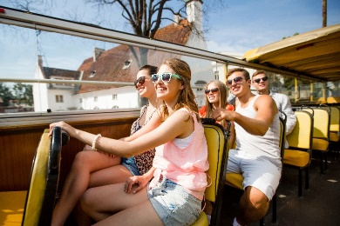
Introduction
A wide range of different types of Tour Guides exist.
This section identifies and describes several common industry classifications of Tourist Guides.

Context for types of Tour Guides
Within the industry it is important to understand:
- Tour Operators can elect to employ a variety of different classifications of Tour Guides – or they may only employ one type depending on the profile of tours they offer
- Individuals can choose to be self-employed – and present/promote themselves as any type of Tour Guide they want to
- Some countries stipulate classifications of Tourist Guides – which underpin their attempts to regulate entrants into the Tour Guiding industry.

Types of Tour Guides
It is common for the following types of Tour Guides to be available for employers and visitors/tour groups to choose from:
On-site attractions guides
These Tour Guides:
- Are specific to one (or a limited number) of venues, attractions, parks, gardens or destinations
- Meet and greet tourists on arrival
- Have an extremely detailed knowledge of the site they are working in
- Will be expected to promote sales within the site/attraction
- Manage tourists and visitors while they are on-site
- Will frequently:
- Lead on-site tours
- Conduct demonstrations relevant to the site/type of attraction
- Supervise activities – such as experiential learning
- Provide commentaries
- Drive site-specific transport/vehicles
- Organise and monitor on-site inclusions – such as meals, photo opportunities, displays, events, distribution of materials, rides, games
- Farewell visitors and encourage repeat and referral business.

City guides
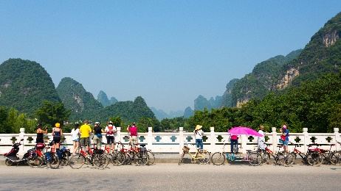
These Tour Guides:
- Specialise in leading tours of one or more cities
- May conduct:
- ‘City walks’
- ‘Bicycle tours’
- ‘Hop on, hop off’ tours – using public transport
- Tours of a specific area of a city
- Tours of specific business/property types within the city – such as fashion and clothing houses, restaurants, electronic wholesalers/retailers
- Tours of certain lifestyle/life choices – such as medicine, nightlife, arts and culture, museums, history, activity-based options
- Often work closely with:
- Councils
- Tourism bodies including semi=government authorities
- Local businesses.
Government guides
Government guides are employed by the government or government-funded bodies or agencies.
These Tour Guides:
- Are employed by the government – but may not be obviously designated (to visitors/tourists) as government employees
- Need to comply with pre-requisite compliance requirements – which often relates to minimum requirements for experience as well as holding designated qualifications and/or a local tour licence/permit
- Are often to communicate prescribed information to visitors – as part of the government effort to impart knowledge and/or promote a certain point of view or initiative
- May:
- Lead tours of government buildings and other government-owned and managed destinations
- Conduct tours of general areas, cities and other attractions.

Specialised guides
These Tour Guides:
- Specialise on one or more type of tours – such as, for example:
- Action and adventure tours
- Historic tours
- Culture tours
- The Arts
- Eco-tourism and nature
- Must have:
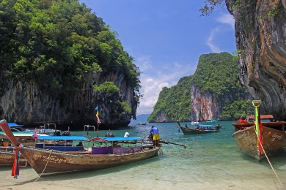
- Extensive knowledge of the areas they are specialising in
- Sound skills relating to the activities which are the focus of their tours
- Often operate as other guide types – in addition to their chosen specialisation
- May be classified as such by local regulations – for example Singapore STG classification: see http://guides-online.visitsingapore.com/tgls/application/STG_FAQ_App.pdf
Independent guide
An independent guide:
- Is self-employed
- May also work for Tour Operators, Government agencies or attractions or destinations on a contractual basis – in any Tour Guide capacity as listed in this section
- May need to be registered by local authorities – in order to function in this capacity
- May need to ensure they meet local compliance obligations imposed by law/the authorities – which may relate to:
- Advertising and promotion
- Conduct and ethical practices – including complaint resolution
- Insurance coverage.
Business and industry guides
These Tourist Guides:
- Are ‘Specialised guides’ who focus on leading tours to:
- Nominated business houses
- Specific industry types or sectors
- May be self-employed or employed by the businesses/industries they serve
- Can operate (wholly or partially) on a ‘commission basis – based on the sales made to visitors/tour groups while they are at individual establishments.
Duration-based guides
These Tour Guides may be:
- One-day Tour guides – leading tours of (generally) six to twelve hours duration
- Extended Tour Guides – conducting multiple day tours.
They:
- May be required to drive a vehicle – or may work in conjunction with a dedicated driver
- May be required to cook/prepare meals – or may work with a dedicated cook
- Can be a generalist Tour Guide – with general knowledge about an area and/or a range of topics, or a Specialised Tourist Guide
- May be required to arrange and supervise accommodation of tour group members
- Will need exceptional levels of interpersonal and communication skills – given the length and nature of the contact they have with visitors
- Must monitor group dynamics more than other types of Tour Guides given the longer duration of tours and the greater potential for problems to arise.
Driver guide
These Tour Guides:
- May be any classification of Tour Guide as identified above – who combine their other Tour Guide duties with driving a vehicle
- Often need to hold a nominated type of driving licence as appropriate to the type of vehicle being driven – which may be:
- A car or van with limited passenger capacity
- A four-wheel drive vehicle – especially on adventure/remote area tours
- A bus or coach
- May drive:
- Vehicles on public roads
- Conveyances within the boundaries of attractions – such as tractor-trains
- Will often need to have:
- Specialist driving training
- Nominated experience/ability with vehicle maintenance and repairs.
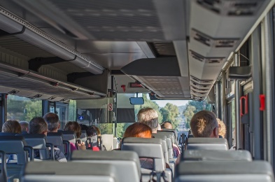

1.3 Identify and differentiate between the groups a tour guide may lead

Introduction
Tour Guides may be asked to lead a diversity of tour groups.
This section identifies and describes groups which may be led.

Tour terms
All-inclusive tour
An all-inclusive tour is (more or less) what the name implies.
It is a tour where all of the inclusions are included in the purchase price. All inclusive tours generally apply to coach and sea travel/cruises.
The exact nature of these inclusions will vary depending on the tour and, of course, they can also vary between providers/Tour Operators.
Common inclusions are:
- Tickets/fares/travel
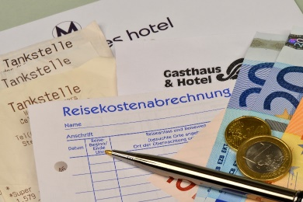
- Transfers
- Accommodation
- Meals
- Certain beverages – alcohol is usually not included
- Side trips and sight-seeing
- Listed activities – excursions, attractions, events, entertainment
- On-site services/facilities – gymnasium, sports, spa, games
- Tips/gratuities.
Escorted tour
An escorted tour is a group tour where the travel agent or organising agency provides a Tour Guide (or tour group leader or ‘tour director’) who escorts the tour group members for the duration of the tour.
An escorted tour is distinct from a self-guided tour where the traveller makes their own arrangements and makes their own way.
Escorted tours may be sea-based or land-based, and generally all inclusive.
Many people prefer an escorted tour as they fell safer and believe they will have less problems and/or get more from the experience when in the presence of an experienced leader.
The tour leader will:
- Assist with boarding protocols when getting on a coach, ship, train or other transport
- Facilitate check-in at hotels and entry to attractions and other sites
- Help solve problems which may relate to customs, immigration, local laws and customs
- Provide advice and information in relation to the areas/sires visited
- Liaise as required with local officials, businesses and individuals
- Monitor the safety and security of the group and take appropriate action when needed
- Manage the tour group and address any interpersonal issues which may arise.
Fully independent tour
This is an unescorted tour.
The client purchases a package deal/tour – called a Fully Independent Package – (which may include travel, accommodation, meals, admission to sites/attractions, car hire) from an agent or Tour Operator and then undertakes the trip on their own without a tour leader or Guide.
This gives the customer the benefit of a planned tour but the flexibility/freedom to do (within the constraints of the itinerary) what they want, when they want.
Group inclusive tour
A GIT is a tour arranged for, or bought by, a group from an agent or Tour Operator.
All members of the group follow the same itinerary and have access to the same inclusions.
It may be escorted or unescorted.
It is ‘inclusive’ because it contains the traditional inclusions of travel, accommodation, meals, admissions, insurance, and transfers.
GITs are attractive to groups because the purchase price is usually less than the sum of the elements comprising the package.
Itinerary
An itinerary is the plan for a trip.

Itineraries are developed for travel by air, sea and road (coach trips and extended trips using other land-based options).
An itinerary is commonly provided for every trip and all travel sold, and provided to the client.
It may list:
- Name and contact details of the organisation which has organised/sold the trip, tour or travel
- Name of client
- Dates and times – of travel (arrivals and departures) as well as trip time
- Destinations
- Activities
- Modes of travel
- Transportation details – such as name of vessel, flight number
- Accommodation arrangements – name of facility/hotel, room type, room number, dates
- Terms and conditions – for carriers, accommodation and other service providers
- Specific requirements relating to the travel/destinations – such as:
- Visa requirements
- Health issues
- Time to arrive prior to departure
- Customs and immigration requirements.
When the itinerary is provided the company may also supply additional promotional materials and/or merchandise such as:
- Travel bags
- Luggage tags
- Maps
- Fact/information sheets – about the carriers, destinations, specific topics which may be the focus of the type of trip/travel being undertaken.
Seat in Coach
Also known as ‘Seat in Vehicle’ this term refers to tours where the customer has purchased a ticket (on a coach, or other vehicle).

This provides a much cheaper way of travelling (when compared to a private tour).
Seats may not be ‘allocated’ and a ‘first come, first served’ basis may apply, making this a potential issue for couples, groups and families.
The purchase of a ticket simply guarantees a seat.
Such arrangements are popular and common for airport/cruise centre transfers and for short-distance sight-seeing trips.

Industry dictionaries
To help define industry terms the following online sources may be of use:
- http://www.travel-industry-dictionary.com/
- http://www.traveljargon.org/.

Tour groups
Tour Guides may be required to lead:
- Domestic tour parties – local nationals who wish to participate in a tour experience
- International tour parties – who may be:
- Structured groups engaging in an organised tour – which often are focused on a central theme or range of themes
- FITs participating in random tours, trips or excursions – to suit their individual needs as represented by the type of tour they have chosen.

Tour groups are also known as ‘tour parties’ and they may be:
- Package groups – who have purchased this tour as part of a bigger package, trip or travel arrangements
- These groups may or may not have a specific common interest. Often they are simply general-interest groups who share common demographic characteristics such as age, marital status, and/or country of origin
- Public tour groups – are groups comprising members of the general public
- They are commonly (but not always) characterised by:
- Diversity of characteristics
- Being free-of-charge
- Operating on a first-come, first served basis – that is, often there is no reservation/booking facility
- Relatively short duration
- Students – a growing market for tours is students
- Their tour is generally:
- Arranged by the school they attend
- Conducted to address specific curriculum-based topics
- Required to include experiential learning activities

- Very time-oriented – there are usually strictly defined time parameters for arrival, activities, meals, departures
- Restricted in terms of what the participants can be expected to spend during the tour – student groups historically spend markedly less (on food, merchandise and similar) than other groups
- Families and friends – many operators and destinations actively promote themselves to family groups declaring they are ‘family friendly’
- These groups:
- Expect facilities to support their family orientation – such as baby change facilities, children-friendly menus, games, rides, activities and staff
- Tend to focus expectations and expressions of satisfaction on issues such as relaxation, group experiences, family interactions and time spent together
- Will seek to purchase ‘family tickets’ – as opposed to single tickets
- Clubs and associations – many clubs and associations use tours as:
- Social outings
- Learning experiences
- These groups:
- Expect a dedicated Tour Guide – for their members while they are in attendance
- Generally arrive and depart as a group
- Commonly require meals, entertainment, activities and/or other nominated experiences as arranged with relevant Secretaries or other club/association representatives
- Often undertake tours to coincide with a special event or commemoration
- Senior citizens – as populations age there has been an increase in older people participating in tours
- These groups:
- May have tours arranged by a club or association
- Generally require more leisurely itinerary
- Tend to focus on observation and entertainment – rather than on activity and participation
- Seek knowledge and interaction with others
- Can have specialised dietary needs
- May require transportation in situations where other groups are able/prepared to walk
- Special interest groups – there is really no limit to what groups may be interested in.
- Indicative/representative interests can include:
- Heritage
- Adventure
- Sport
- Culture
- Arts
- Indigenous tourism
- Nature
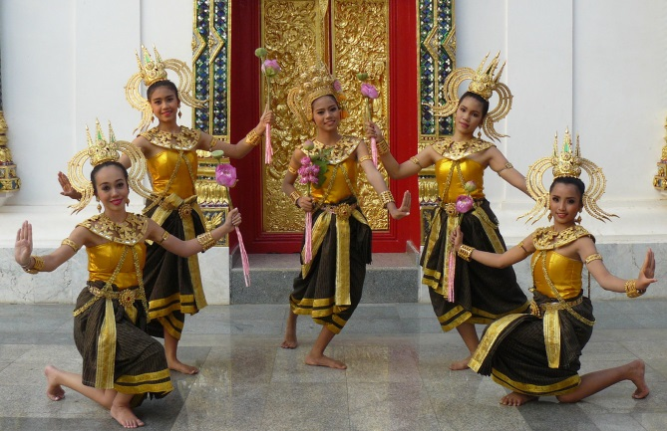
- Eco-tourism.

1.4 Describe the interpretive approach to tour guiding

Introduction
The interpretive approach to guiding has emerged as an effective and successful way to conduct tours.
This section describes what is meant by the ‘interpretive approach’ to guiding and presents the component elements of the approach.

Defining the interpretive approach

The interpretive approach to tour guiding is based on the Latin word interpretari meaning:
- To explain
- To translate
- To interpret.
In essence the primary aims of the interpretive approach are to:
- Inform and educate
- Enrich the experience
- Engage the members of the tour group
- Communicate emotion/feelings as well as facts and figures
- Provide insight.

Elements of the interpretive approach
The interpretive approach includes:
- Engaging participants – a key is to resonate and communicate with the tour group members of the tour
- The aim is for active involvement of the audience where ‘active involvement may relate to physical or cerebral activity
- Providing a verbal commentary – to explain and translate the characteristics, significance and features of the tour
- Identifying, explaining and attributing local, cultural and contextual meaning – to sights, activities and other topics which are the focus of the tour

- Facilitating learning – through development of understanding and awareness of the issues/subjects and content and revelation of hidden and/or deeper meanings
- Contextualising the tour – in terms of a local framework, local history, local culture, local issues and local flavour
- Generating and demonstrating respect and appreciation as appropriate to the tour – which may relate to local customs, history, people and the environment
- Being provocative – in terms of encouraging questions, stimulating thought, cultivating curiosity and promoting personal/self-reflection on issues
- Doing whatever is needed to bring the tour to life within the context of the individual tour – which can mean:
- Using costumes
- Telling stories and anecdotes
- Demonstrating
- Involving participants in a variety of ways in different activities
- Meeting/interacting with locals
- Experiential learning
- Building relationships – between tour group members and:
- Locals
- The environment
- Whatever is the focus of the tour.

Online information
Further information can be found at:
- http://www.interpretiveguides.org/dbfiles/2.pdf - Handbook for interpretive guides: Interpretive Guides Association
- http://www.resourcesandenergy.nsw.gov.au/__data/assets/pdf_file/0004/358555/GGHG_2010_Cove.pdf - The Essential Role of Interpretive Guiding in Ensuring Understanding and Conservation of Sensitive Geosites
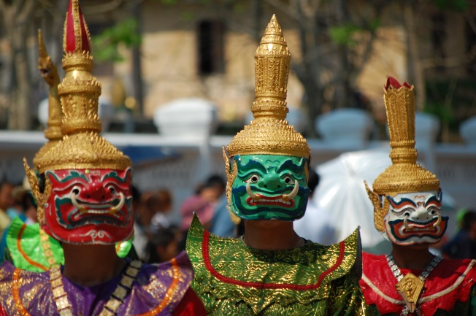

1.5 Identify tour types

Introduction
It is possible to categorise tours into different types.
This section identifies basic tour types and gives examples of each.

Basic tour types
In addition to the classification of tours outlined in section 1.3 tours may be further categorised into generic tour classifications such as:
- Site-based tours
- Special interest tours
- Water-based tours
- Land-based tours.

Site-based tours
Site-based tours may include:
- Museums, historic sites and galleries tours
- Zoos, preserves and wildlife parks tours
- Gardens, parks, forests and national parks tours
- Tours of factories, businesses, production and processing plants
- Tours of government and semi-government utilities – including power-generating stations, reservoirs and waste-water treatment plants.


Special interest tours
Special interest tours can include:
- Photography tours
- Wildlife tours
- Aerial tours
- Parks and gardens tours
- Sport events/tours – including as participants and observers
- Flora and fauna tours
- Wine and food tours
- Tours of nominated geographical regions, areas and destinations
- Scientific and educational tours.

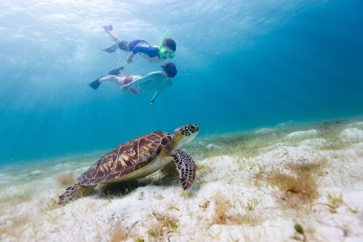
Water-based tours
Water-based tours include:
- Cruises
- Boating and yachting trips
- Snorkelling
- Scuba diving
- Fishing tours.

Land-based tours
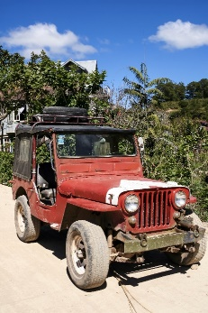
Land-based tours include:
- Four-wheel drive tours
- Remote area tours
- Rail tours
- Bus/coach tours
- Bicycle and motor bike tours
- Walking tours
- Horse and camel
- Caravan and camper tours.
Internet articles
Take the time to read:
- http://www.affordabletours.com/search/Type/ - Different tour types at Affordable Tours.com
- http://www2.amk.fi/digma.fi/www.amk.fi/opintojaksot/050809/1184649944500/1184650138999/1184654457131/1184654823506.html - Types of Tours (VirtuaaliAMK Tourism Intermediaries)
- http://www.theguardian.com/travel/typesoftrip - Types of Trips (The Guardian)
- http://www.jobmonkey.com/landtours/html/types_of_tours.html - Tour Guide Jobs: Types of Tours
- http://psna.ru/index.php?p=ekskursovod&st=en8 – Classifications of Tours

1.6 List the characteristics of a tour guide

Introduction
A set of characteristics required by an effective Tour Guide have emerged over time.
This section provides a list of these characteristics.

Characteristics of an effective Tour Guide
The following are accepted as being essential for Tour Guides:

- Honesty – in relation to:
- Dealing with people
- Handling money
- Looking after people’s property
- What they tell people in terms of commentary
- Practicality – in terms of:
- Resolving issues and solving problems
- Keeping the tour on track and on schedule
- Addressing problems arising
- Responding to requests and being flexible
- Friendliness – towards:
- People of all ages
- People from all countries
- Those who most need it
- Those who are having a bad day
- Those who appear excluded from the tour
- Willingness to serve – with reference to:
- Demonstrating service as a pleasure and not a chore
- Offering to help without waiting to be asked
- Predicting and avoiding problems
- Smiling
- Asking lots of questions
- Local knowledge – as it applies:
- Currently – knowledge must be up-to-date
- To tour destinations
- To the host country

- Excellent appearance – in terms of
- Personal presentation
- Personal hygiene
- A range of skills, knowledge and abilities to conduct/lead the tour for which they have responsibility – see next section.

Online references
- Viator Travel Blog (at http://travelblog.viator.com/top-10-characteristics-of-a-great-tour-guide/) in an article titled ‘Top 10 Characteristics of a Great Tour Guide’ identifies these characteristics as:
- Understandable
- Punctual
- Friendly
- Knowledgeable
- Engaging
- Interactive
- Funny
- Observant
- Good pacing
- Flexible.
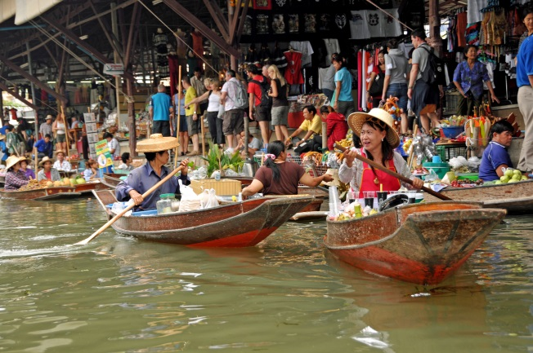

1.7 Describe tour guiding principles


Introduction
Employers and tour group members expect all Tourist Guides to operate according to accepted tour guiding principles.
This section gives a context for such principles and identifies what they are.

Context
Tour guiding principles are guidelines governing how Tour Guides operate and function.
The principles govern and control the thoughts, action and speech of Tour Guides in their day-to-day working life.
Tour guiding principles can exist in a number of ways:
- They can be requirements imposed on Tour Guides by their employer – as part of the terms and conditions of employment with a Tour Operator
- They may be requirements imposed by a governing body (a government agency or a peak industry body) in the form of a Code of Conduct or similar – designed to give tourists confidence in the services provided by Tour Operators who subscribe to the Code
- They can flow from standard ethical business practices – which demand honesty, accountability and integrity from all organisations regardless of the type of business they operate
- They have evolved over time – in response to issues and problems encountered, feedback from tour group members, market research, common sense and action taken by other businesses in other industry types and sectors.

Tour guiding principles
The following list is indicative of what exists and provides a sound basis for the delivery of professional guiding services.
Need to ensure the safety and security
This applies to:
- Tour group members
- Their property
- Assets of the employer
- Property owned by businesses/sites and people/communities visited.
It also embraces need for:
- Risk management – including risk identification and assessment, and the implementation of risk control for tours
- Development of contingency plans – to address identified emergency conditions
- Training to enable safe and secure operation of tours
- Equipment, facilities and technology to support tour safety and security.
Need for care and respect
This needs to be demonstrated and shown towards:

- The employer
- The tour group members
- The host country
- The sites/destinations to be visited.
- Need for appropriate skills and abilities
- This highlights the need for Tour Guides to possess the necessary competencies to enable them to conduct/lead the tour/s for which they have responsibility.
- In general these can be expected to include:
- Unique skills relevant to the type of tour being guided – which may (for example) include ability to drive a bus, skills in cooking, language skills as well as abilities related specifically to the type/nature of the tour such as climbing skills, white water rafting skills, animal handling skills, motor bike riding skills
- Communication and interpersonal skills
- Negotiation and conflict resolution skills
- Planning, researching, organising and strategic thinking skills
- Risk and emergency management skills
- First aid skills and the ability to respond to accidents
- Ability to operate basic emergency equipment and communication systems
- Leadership and control skills
- Need for knowledge
- Every Tour Guide must have:
- Comprehensive, accurate and current knowledge of:
- The host country
- All areas, businesses, attractions, sites, venues and destinations to be visited on tour
- Local culture, customs, language, transport, currency, services, facilities, foods
- The Tour Operator and the services/tours provided
- Ability to source information as required to address questions/issues where the information is not known.
- Need to provide a positive and memorable tour
- This embraces requirements to:
- Make all tours interesting and engaging
- Provide a tour meeting identified needs of tour group members
- Give informative commentary

- Include interactive experiences
- Ensure all tour group members feel included/part of the tour.
- Need for ethical conduct
- This requires Tour Guides to:
- Act in the best interests of the tour group
- Disclose any personal interests, family connections or financial arrangements with sites, businesses or destinations visited on tour
- Be honest in all dealings and statements
- Never be intentionally misleading or deceitful
- Obey all rules, laws, regulations and company policies
- Not tout for tips/gratuities.
- Need to cater for special needs individuals and groups
- This requires taking appropriate action to effectively accommodate:
- Visitors with language barriers/difficulties
- People with physical or mental disabilities
- Those with limited mobility or other sensory acuity
- Certain age groups – with a focus on the very young and the very old.
- Standard protocols for dealing with special needs participants include:
- Recognise their special need to indicate awareness of it – this means verbally acknowledging/mentioning the need and how this will impact things for the visitor/tour
- Explain arrangements which have been made – to accommodate those needs (where applicable): this demonstrates requests made by the group have been received and actioned and/or willingness to be of service/be accommodating of special needs
- Identify the facilities available – within the site/venue/area to meet those needs, and advising these will be pointed out, implemented as and when appropriate
- Empathise with their situation – without being condescending, flippant or demeaning them in front of others in the group
- Be respectful and never make special needs people think they are being done a favour by meeting their special needs – or that they have created ‘extra work’
- Never raise false expectations – in general terms:
- Follow internal policies and procedures – to the extent of individual scope of authority
- Tell them what can be done to meet their need – if anything: try/make an effort to accommodate their needs
- Never over-promise what can be done – they are better off knowing right from the start if their need cannot be met
- Contact management or another worker at the site/venue to determine if they can assist in meeting the special need
- Apologise where a special need cannot be accommodated.

Online information
The following sites (and those listed in section 2.1) provide further information on this important topic:
http://www.toursbylocals.com/TBL/WebObjects/ToursByLocals.woa/1/wa/textPopup?wosid=MGGNmilnEdy0tGBZHVGdbw&c=16&t=Tour+Guide+Business+Principles&s1=&s2= - Tour Guide Business Principles
http://localprivatetourguides.blogspot.com.au/2010/11/dressing-code-for-tour-guides.html - Dressing code for tour guides
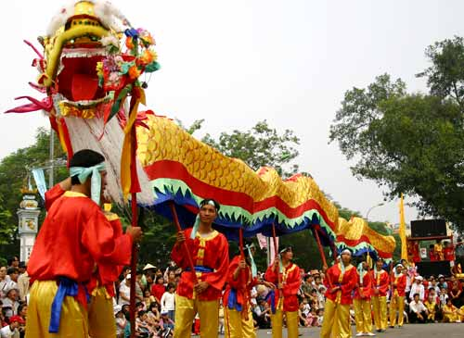
Work Projects
It is a requirement of this Unit you complete Work Projects as advised by your Trainer. You must submit documentation, suitable evidence or other relevant proof of completion of the project to your Trainer by the agreed date.
1.1 Interview the owner, a manager or an experienced Tour Guide in a tour operating business in your home area.
Discuss the following topics/questions with them and prepare and present a written submission which reflects their responses:
- What do they see as being the roles, functions and responsibilities of a tour guide?
- What different types of tour guides do they know of and employ?
- What different types of tours do they offer?
- What are the profiles/characteristics of different groups they service?
- How do they define the interpretive approach to tour guiding and how do their Tour Guides deliver this approach?
- What do they believe to be the essential/necessary characteristics of an effective Tour Guide?
- What do they and their business regard as essential tour guiding principles which all Tour Guides they employ must adhere to?

Summary

Describe the context for the delivery of guiding services
When describing the context for the delivery of guiding services:
- Identify the roles, functions and responsibilities of the Tour Guide as prescribed/required by the employer and tour group members
- Differentiate between types of tours and tour guides
- Determine the characteristics of and differences between the profiles of regular/common tour group members
- Learn industry-related and tour-related terminology
- Understand and be able to apply the interpretive approach to guiding
- Demonstrate necessary characteristics of an effective Tour Guide
- Identify and apply accepted/required tour guide principles.

Element 2:
Develop guiding skills and knowledge

2.1 Identify guide information sources and contacts

Introduction
An essential starting point in developing guiding skills and knowledge is to identify guide information sources and contacts.
This section lists a range of these sources and contacts.

Sources and contacts
Tour Operators and wholesalers
These are excellent sources of:

- Sample tour and travel packages
- Available tour options and inclusions
- Schedules
- Prices
- Terms and conditions
- Policies and procedures
- Insight into:
- Customers, visitors and tour groups
- Tourist needs, wants and preferences
- Experiences with groups.
Venue operators
These provide excellent information in relation to:
- Promotional and advertising brochures and flyers
- Opening days and times
- Entry fees
- Attractions, displays and events
- Facilities provided
- Meals/refreshments available
- Location and access
- Booking provisions and ticketing.

Internet
The internet is an excellent information source but the following advice may be of use:
- Never use the internet only for references/information – it is important to make direct contact with ‘real people’
- Travel and tourism blogs can be worthwhile sources for gauging general client thoughts about aspects of the industry – all manner of issues are discussed including agencies and their prices and service; reliability and credibility of providers; satisfaction with carriers, destinations and attractions plus a wide range of other topics
- See the following:
- http://www.invesp.com/blog-rank/General_Travel
- http://konector.com/best-blogs/best-travel-blogs
- http://www.livingthedreamrtw.com/p/massive-list-of-travel-bloggers.html
- http://www.thelongestwayhome.com/travel-blog-directory.html
- Create a ‘Travel’ folder under ‘Favourites’ and ‘Bookmark’ any site of interest – so useful sites can easily be re-visited
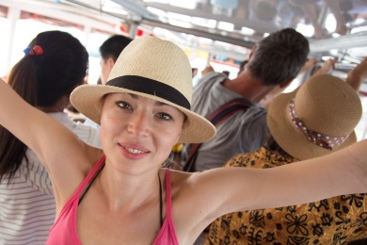
- Be prepared to:
- Print relevant pages/information
- Follow links on pages to other sites
- Take notes from the pages visited
- Follow-up – take the time to (as appropriate):
- Register for free updates, e-magazines, reports
- Make personal contact with the organisation – to grow personal network of industry contacts.
Literature
Good sources of information are:
- Guide books – such as Lonely Planet, Access, Fodor’s, National Geographic, Frommer’s
- Newspaper and magazine articles
- Local telephone books
- History books
- Reports
- Travel and tour/promotional brochures.
Network of personal contacts
It is vital to develop an extensive network of personal contacts.
Those in the network could include:
- A selection of Tour Guides – from different employers and who conduct a variety of different tour types
- Local Tour Operators and travel agents
- Carriers
- Venue operators
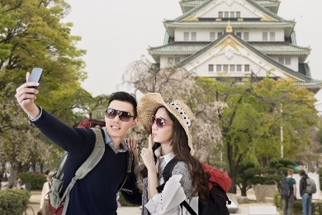
- Government officials
- People at local Tourist Information centres.
It is important there is two-way communication with people in the network.
Formal industry organisations
These can include:
- Professional Tour Guide bodies and peak industry associations
- Government and semi-government authorities
- Licensing agencies.
Local identities
These can comprise:
- Community leaders and elders
- People who have a long time in the area
- Individuals with detailed/in-depth knowledge of certain local aspects
- Local celebrities and sports stars.
Industry Codes
These provide details and insight into ethics and practices deemed necessary/acceptable for the industry.
Refer the following for detail:
http://www.wftga.org/tourist-guiding/code-guiding-practice - The code of guiding practice
http://washingtondctourguides.com/about-the-guild/code-of-ethics - Professional guide’s code of ethics and business practice
http://www.tichk.org/public/website/en/guides/code/html - Code of Conduct for Tourist Guides
http://learnline.cdu.edu.au/tourism/uluru/downloads/readings/reading20_code_of_conduct.pdf - Tour guide code of practice
http://www.cato.asn.au/About/code-of-ethics - Code of Ethics: Council of Australian Tour Operators.

2.2 Acquire and up-date industry skills and knowledge

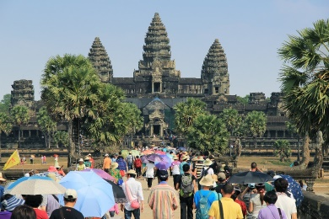
Introduction
Once relevant guide information sources and contacts have been identified they need to be used.
This section identifies activities involved in using these sources and contacts to acquire and up-date guiding skills as well as industry skills and knowledge.

Context of activities
Activities associated with acquiring and up-dating skills and knowledge are:
- Readily available – there are many of them, easily accessible
- Relatively inexpensive to use/access – most require an investment of time rather than large amounts of money.

Examples of activities
Activities may include:
Attending industry seminars
These are advertised in the media, industry magazines and actively promoted through industry associations, websites, newsletters and direct mail.
They may be held locally or elsewhere and often feature a wide array of
- Exhibitors
- Speakers
- Products and services.
There may be a need to pay to attend or they may be free of charge – there is often a need to register interest or intention to attend to facilitate catering and other arrangements.
They are an excellent opportunity for:
- Expanding personal networks
- Learning about new products, services, packages, initiatives, deals, providers and industry issues.
Partaking in industry and related training courses
This training may be provided by:
- Industry stakeholders such as carriers, providers, suppliers, key industry organisations, representative bodies and/or government organisations/authorities
- Training institutions – both private and public.

These courses may:
- Be free or fee-for-service
- Result in formal or informal outcomes – formal outcomes provide recognised/accredited qualification/s and will be formally assessed
- Conducted on-site in organisations – or at some other remote location such as a training facility, supplier warehouse or government building
- Feature a mix of theory and practical training.
Inherent in this option is also the potential to arrange for objective evaluation and assessment of personal skill and knowledge levels to gain recognition/certification.
Undertaking FAM tours
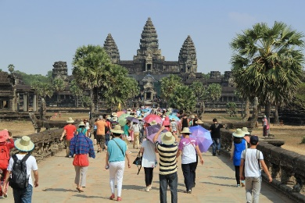
These are commonplace within the industry.
They are operated by:
- Industry attractions
- Venues
- Sites.
- They are provided:
- Free of charge
- To industry personnel
- In order to make industry personnel aware of (‘familiar with’) the destination so they will promote it/recommend it to visitors and tourists.
- They need to be arranged in advance for a mutually convenient time, usually by contacting the destination and making a request.
Joining a professional guiding association
It is strongly recommended all Tour Guide join at least one recognised professional guiding association.
The association may be:
- A local Chapter/Branch of a larger organisation
- A stand-alone local body.
- Many Tour Guides belong to more than one such organisation.
- In some cases, being a member of a guiding association may be a legislated requirement where the body oversees/administers Tourist Guides licences/permits
- Reasons to join these associations include:
- Meeting other people with similar professional interests
- An opportunity to learn from, and share experiences with, like-minded people
- Access to information directly impacting the role of Tour Guide – including data revealed as a result of primary market research activities

- Advice on a host of Tour Guiding issues – such as:
- Employment opportunities
- Employment terms and conditions
- Career potential
- Legislated obligations imposed on Tour Guides and operators
- A range of associated benefits – such as:
- Regular meetings and newsletters
- Discounts when attending industry events and/or when purchasing goods and services from nominated suppliers.
Visit the following to gain an understanding of what certain associations have to offer:
http://www.wftga.org/ - World Federation of Tourist Guide Associations
http://www.seatga.org/ - South East Asia Tourist Guides Association
http://stga.com.my/ - Sabah Tourist Guides Association
http://www.societyoftouristguides.org.sg/ - Society of Tourist Guides Singapore.
Undertaking formal and informal research

Formal research relates to:
- Reading relevant text books
- Undertaking formal courses of study
- Reading industry reports
- Attending industry-based events.
Informal research relates to:
- Talking to network of contacts
- Reading general media articles
- Speaking with tourists/visitors
- Visiting destinations, sites and attractions.
Practicing required skills
This means implementing newly learned competencies so they become familiar and easy to perform.
It relates to the concepts of:
- Drill
- Repetition
- Role plays
- Practical exercises
- Demonstrations.
The practice may:
- Occur in an actual industry setting
- Take place in a simulated environment
- Be undertaken while acting as an assistant to another (or bona fide) tour guide.

2.3 Identify legal, ethical and safety requirements that apply to provision of guiding services

Introduction

An essential aspect of developing guiding skills and knowledge is the acquisition of knowledge relating to legal, ethical and safety issues in guiding.
This section examines these requirements in relation to criminal and civil liability and should be read in conjunction with section 1.7.

Criminal and civil liability
Criminal liability
Criminal liability refers to situations where a person is found ‘guilty’ of an offence.
Guilt must be proved ‘beyond reasonable doubt’.
Action is taken against the person by the authorities.
A guilty decision may result in:
- A fine
- Imprisonment
- Other outcomes such as business closure, licence/permit cancelation or suspension, legally-binding directive.
Civil liability
Civil liability refers to situations where a person is found ‘liable’ in relation to an occurrence.
‘Liability’ only needs to be proven ‘on the balance of probabilities’.
Action is taken against the person by another person or a business for things such as:
- Protecting their personal interests
- Failing to take reasonable care
- Breach of contract.
Being found liable can result in:
- Damages being awarded against the person found liable
- An injunction being issues forcing them to do, or refrain from doing, certain thing/s.
Combination of the two
In some situations the same event/occurrence can give rise to:
- Criminal charges
- Civil action.

Legal
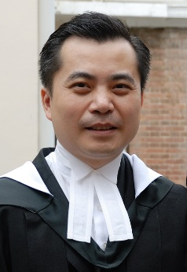
It is important for Tour Guides to be aware of the following key legal issues:
Duty of care
- All Tour Guides are under a common law Duty of Care liability to take ‘reasonable’ care of the people they are leading/providing guiding services to
- In essence this means they must avoid causing ‘foreseeable’ harm to any tour group members
- Failure to discharge this Duty of Care can result in being sued for negligence
- Different types/levels of negligence exist:
- Contributory negligence
- Gross negligence
- Vicarious liability
- Comparative negligence
- The various classifications of negligence help determine the penalty if found liable.
Advertising
All Tour Operators and Tour Guides are under a legal obligation to ensure their advertising complies with standard ‘fair trading’ requirements.
Advertising in this context refers to:
- Printed materials, promotional brochures or statements made about tours, Tour Guides (ability, experience, skills, knowledge), destinations, products, services
- Verbal statement made in relation to any of the above.
The basic requirement is all such claims must be truthful and honest – they must not be:
- False
- Misleading
- Deceptive.
Breaching these requirements may give rise to criminal and civil action.
Breach of contract
A contract is a legally-binding agreement which imposes rights and obligations on all parties to it.
Essentially the parties agree/promise to do something, or refrain from doing something, in return for something (‘consideration’). There must be a formal ‘offer’ and ‘acceptance’ for a contract to exist.
When a visitor/tourist buys a ticket they enter into a contract with the Tour Operator.
They have paid money (their consideration) and the Tour Operator agrees/promises to provide an agreed tour with stated/advertised inclusions to nominated destinations subject to conditions, terms and warranties imposed by the business as part of the transaction.
Where the Tour Operator or Tour Guide fails to deliver the promises the aggrieved party can choose to take a civil action for breach of contract.
In Court the tourist will need to provide evidence to support their claim and the system will determine if the action/inaction was a breach of a term, condition, warranty or guarantee and make a decision based on the evidence and the seriousness of the breach.
Even though the Courts may not allocate large amounts in the way of ‘damages’ many of these civil cases attract media attention which is far more damaging to the operator than the amounts awarded by the Courts.

Complying with legislation
It is a standard procedure all Tour Guides comply with all relevant legislation.
In practice this means they must identify and meet all requirements and regulations:
- Applicable specifically to Tour Guides – where such legislation exists
- Applicable in their host country
- Applicable in different countries they visit/lead tours to
- Applicable to all activities undertaken on tour.
It is worth noting:
- Employers may be vicariously liable for the actions of their staff
- Employees do not have a legal defence if they commit an offence because their employer told them to break or ignore a law.

Ethical
Standard ethical issues which impact on Tour Guides include the need to:
- Be truthful and honest regarding information provided to customers, including a total ban on fabrication of information
- Provide products and services in accordance with advertised itinerary and promises
- Demonstrate respect for local communities, local culture, sites and the environment, including the objective of minimal impact tour guiding practices aimed at sustainable operations
- Maintain principled relationships with key stakeholders.

Safety
Specific safety requirements will vary depending on:
- Tour type
- Destinations visited
- Activities being conducted
- Size of the group
- Composition and characteristics of the tour group
- Weather and local environmental and other conditions.
Examples of what may apply include:
- Complying with occupational health, safety and welfare requirements – as they apply to individual tours and situations
- Ensuring the responsible behaviour of customers – including:
- Controlling unacceptable behaviour
- Modifying unsafe behaviour
- Checking equipment, locations, facilities and the environment – prior to engaging with or using same so there is full knowledge of applicable conditions/the environment
- Practising implementation of prescribed emergency responses – to identified emergency situations
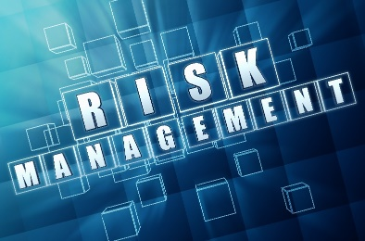
- Managing risk – including:
- Risk identification
- Risk assessment
- Risk control
- Explanation of potential hazards to others
- Removing identified dangerous activities or undertakings from the itinerary – where necessary and (if possible) replacing them with an appropriate alternative
- Abandoning the tour under conditions where the safety of customers cannot be guaranteed – and adhering to company policy regarding reimbursement of payment
- Providing safety advice, directions and demonstrations to customers – including:
- Monitoring of the implementation of advice
- Provision of supplementary guidance as necessary
- Actively participating in discussions regarding the development of new tours and itineraries and contributing personal experiences and lessons learned from previous tours.

Work Projects
It is a requirement of this Unit you complete Work Projects as advised by your Trainer. You must submit documentation, suitable evidence or other relevant proof of completion of the project to your Trainer by the agreed date.
2.1 Identify an employer you want to work for and the type of tours you want to lead for this organisation.
Using this as the basis for your response:
- Identify guide information sources and contacts which can be used to assist with gaining, maintaining and updating relevant guiding skills and knowledge
- Prepare a list of necessary skills and knowledge required to enable effective guiding for the identified employer and tour type/s
- Provide evidence of having used some of the identified guide information sources and contacts to obtain guiding information
- Identify and describe the legal, ethical and safety requirements that apply to the provision of guiding services for the identified employer and tour type/s.

Summary

Develop guiding skills and knowledge
When developing guiding skills and knowledge:
- Identify relevant sources and contacts to capture guiding information
- Research/use identified information sources
- Be willing and prepared to update industry skills and knowledge
- Attend industry events
- Gain first-hand experiences of a variety of tours
- Join industry associations
- Practice necessary skills
- Identify and apply necessary legal, ethical and safety requirements
- Realise the need to guard against possible legal action which may be taken by tour group members.

Element 3: Provide guiding services

3.1 Demonstrate the skills and knowledge necessary to guide tours

Introduction
Leading tours requires demonstration of a wide set of skills and application of a diverse body of knowledge.
This section identifies activities necessary in this regard.


Basic classification of skills and knowledge
Tour Guide requirements can be classified into the following sections to assist with identifying and applying what is necessary:
- Pre-arrival activities – concentrating on tasks to be completed before tour groups arrive for their tours
- Pre-departure checks –featuring activities necessary to ensure safe and compliant operation of the tour in accordance with legal requirements and promotions
- During tour activities – relating to all the duties required to lead the tour and conduct activities
- On-departure/post-tour activities – focussing on administrative work required by the employer to finalise the departure of tours.

Pre-arrival activities
The skills and knowledge which may need to be demonstrated at this stage can include any or all of the following:
Checking of arrival schedules
To ensure:
- Capturing hard copy information about tours and groups for the day/shift
- Knowledge of times groups are arriving
- Knowledge about composition of group
- Knowledge about any issue/detail to be clarified and/or obtained in relation to the group/individual members of the group
- Knowledge about how groups/members are arriving – public transport, private vehicle, shuttle bus
- Knowledge about exactly where they will be arriving – booking office, departure lounge, outside on footpath/in car park (‘muster point’).

Checking reservations
To gain knowledge of:
- Payments made and/or to be collected prior to departure
- Special requests made by tour groups/members – and:
- Tour Operator responses to these
- Tour Guide commitments in this regard
- Types of bookings which have been made – and how (if applicable) this impacts inclusions and/or tour guiding to be provided
- Seats/tickets remaining available for sale – so action can be taken to promote and sell these.
Verifying itinerary
This may involve:

- Contacting destinations and providers – and confirming arrangements
- Determining weather and other local conditions – and factoring this knowledge into plans
- Arranging suitable alternatives – where necessary
- Confirming basics of the tour – in relation to knowledge of:
- Departure and arrival times
- Transportation
- Routes
- Inclusions
- Breaks and meals/refreshments
- Activities.
Collecting resources relevant to the tour to be conducted
This can require:
- Obtaining and checking guide kit – as appropriate for the individual needs of specific tour types which will contain essential items to enable the effective and safe conduct of the tour, such as:
- Maps
- First aid kits
- Communications devices
- Pen and paper and nominated internal forms
- Contact List
- Tour notes and script for commentary
- Prop kit


- Obtaining resources and other materials for distribution to tour group members – such as:
- Information brochures and Fact Sheets
- Safety advice and information
- Tour maps
- Specific information relating to individual destinations, events, activities on tour
- Obtaining necessary vouchers to reflect tour group numbers and inclusions – such as for:
- Entry to venues/destinations
- Meals/food and beverages
- Merchandise and nominated services
- Discounts on certain purchases.
Testing items
This may require:
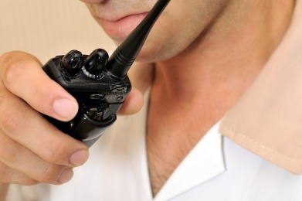
- Testing communication items/devices:
- Microphones on PA systems
- Megaphones
- Walkie-talkies/two-way radios
- Cell phones
- Pagers
- Portable PA systems
- Laser light pointers
- Personal audio facilities – these are more commonly used for self-guided tours but can be used for certain portions of a longer tour – for example, the headset and player unit may be distributed to tour group members when they are given 90 minutes to wander at their leisure through the museum part of a larger site
- Audio-visual equipment – where it is to be used for presentations:
- PowerPoint/data projectors and screen
- Overhead projectors and screen
- DVD players and monitor
- Movie projectors and screen
- Computers – and internet connection where this will form part of the tour or a component of a presentation or tour activity
- Testing/checking sporting equipment – as required for games and sporting activities to be played:
- Bats, racquets and balls
- Boats and cars (pedal cars, luge cars; motorised kiddies cars)
- Protective clothing and equipment
- Checking items required to enable tour group members to participate in scheduled activities:
- Ingredients people are going to use
- Utensils and items of hand-held or powered equipment.
Preparing scripted commentaries

A scripted commentary is a prepared talk about identified topics of interest to a group of tour group members.
The scripted commentary may be prepared by the agency and provided for use, or there may be a need to develop a scripted commentary for a certain tour, group and/to meet special requests/needs of a tour.
A scripted commentary should be thought of as a guide about what needs to be said rather than a complete list of everything that needs to be said during a tour.
There will always be a need to provide some unscripted commentary to supplement whatever scripted commentary is prepared.
Unscripted commentary refers to the situation where information is provided to the tour throughout the tour but reference is not made to a script when doing so.
The following is a guide for preparing a scripted commentary:
- Writing a commentary takes time – it cannot be done on-the-spot and rarely on-the-day it is required. Writing a commentary can take weeks
- Research the tour – knowledge is a critical underpinning element of every effective and engaging commentary:
- Research is required about what the visitors want, need and/or prefer to hear about
- Research is essential about the site/location/venue where the tour will be delivered to obtain statistics (people just love figures as part of a commentary – height of things, number of things, weight of things, speed of things, temperatures, size/dimensions), history, details about the facilities, interesting facts about the area or venue, names of owners … and, of course, loads of facts/details about anything which is the main focus of the tour
- For example:
- If preparing a commentary for a zoo it is vital to know all there is to know about the animals, their habitat and their feeding habits
- If preparing a script for an historical tour it is critical to know important dates, events, people, and sites
- Check the advertising undertaken by the tour company, the site or the venue to identify topics promoted to visitors – and then ensure these are covered by the commentary in order to meet expectations and advertised promises
- Know the route – the commentary will/should describe and provide information about the venue/site in general but (more so) on what is visible on the tour itself. This means a need to cover in some detail all buildings, natural and built attractions, events as the tour sees them/passes them

- There is no need to cover – or cover in far less detail – buildings and similar not viewed or visited as part of the tour however there still remains a need to have knowledge about them
- The scripting process should involve others – to:
- Contribute ideas
- Provide information, facts and figures
- Bounce ideas off
- Practice on
- Experience some other commentaries – before starting to develop the commentary to learn from:
- What they do/say
- How they do and say it
- When they do and say things
- The amount of commentary they provide
- Avoid personal opinions, thoughts, beliefs and prejudices – a commentary is not the place to air personal views
- Avoid inappropriate language – such as:
- Swearing/bad language
- Racist terms
- Gender bias
- Prepare a draft – and then revise it time and time again until it has been polished to the required standard
- ‘Speak’ the commentary when trialling it – it must be spoken aloud to get a proper feel of it. Simply reading it in the mind will not do it
- Read it out loud to others for their feedback/comment
- Record it and listen to it and self-critique
- Write the script from the guest/visitor perspective – for example if at the front of a bus or tractor train and facing backwards towards the visitors, the landmarks must be identified from their viewpoint
- For example, do not say “On my right is a fine example of …”, instead say ‘On your left”
- Use simple, plain language – this is not to infer a need to be condescending but highlights the need to keep things simple and easy to understand
- Use simple sentences, not long ones and use simple words and not complex ones
- The easier a commentary is for people to understand, the more they will enjoy it, the more they will learn from it, the more they will engage with the tour and the more satisfaction they will get from the tour
- The commentary should reflect the nature of the tour – for example a tour focussing on nature may be expansive and emphasise grandeur and awesome natural spectacle. A tour of prison, museum or war-related tour would take a vastly different approach and be more restrained, respectful and serious
- Revise the scripted commentary – as required when things change to keep it current
- Practice the commentary before using/delivering it – which means:
- Reading it out aloud several times – not just once: five is a minimum
- Reading it in situ – this means walking/driving the tour route and commentating to align with points of interest and items mentioned in the commentary.
- Bringing the standard commentary to life with personal anecdotes or knowledge as appropriate to the venue, topics or interests of the group.

Pre-departure checks
The skills and knowledge which may need to be demonstrated at this stage can include any or all of the following:
Checking tour requirements

This requires talking with other personnel (such as Tour Operator/manager, drivers, assistants, cooks) to:
- Confirm plans/arrangements
- Discuss imposed/necessary changes
- Determine alternatives
- Recap allocated roles and responsibilities.
Preparing transportation
This may require:
- Undertaking mandatory safety checks/inspections
- Cleaning
- Replenishment of on-board supplies.
Processing tour resources
This can include the need to:
- Requisition/order resources – as required based on tour type, group, numbers and budget
- Obtain and check/inspect resources provided – to ensure integrity, sufficiency, appropriateness and safety
- Loading/stowing items on transport.
Completing documentation
This will relate to:
- Vehicle/transportation documentation/logs – recording mileage, dates, driver name, destination, tour type
- Internal paperwork to record resources used – by tour
- Time sheets
- Tour manifests
- Signing for items – keys, credit cards, acknowledgement of directives/orders from management, cash advances.
Checking of personal appearance
This will require attention to:
- Standards of dress and grooming required by the employer
- Standards of decency and common sense
- Requirements of the tour to be conducted
- Personal hygiene.

During tour activities
The skills and knowledge which may need to be demonstrated at this stage can include any or all of the following:

Greeting tour group/tour group members
This requires:
- Being there – it is important to be there before the advertised/promised starting time and before tourists arrive to demonstrate preparedness for their arrival
- A verbal welcome – to the group and individuals
- Introducing self – and role
- Thanking them – for arriving/taking the tour
- Smiling – the universal language
- Making necessary introductions – to other tour group members and to other staff Tour Guides who will be on tour
- Establishing a rapport with the group/individuals.
Confirming tour details
This can embrace the need to:
- Verbally provide itinerary details – highlighting points of interest and special events and arrangements
- Distribute materials – such as name tags, itineraries, tickets, vouchers, handouts, tour materials
- Include a Q & A session – so participants have an opportunity to clarify issues, ease anxiety and obtain answers to their pressing questions/concerns
- Mention potential hazards – and identify safety protocols and emergency measures which have been established
- Explain tour group management protocols to ensure safety of all and no-one is separated from group or ‘lost’ on tour – covering:
- Muster points
- Need for everyone to check on others
- Use of head counts
- Provision of cell phone number for Tour Guide, driver, Tour Operator for people to use in emergency.
Commencing the tour
This can embrace the need to:

- Do a head count for the tour group – to identify/confirm ‘pax’
- Lead tour group members to vehicle/bus – and assist with boarding
- Explain facilities on board – and any relevant ‘rules’ relating to the transport
- Start the tour on time – so it runs according to schedule: this is important:
- Because destinations, sites and attractions are expecting the tour at set times
- As tour group members may have made other arrangements based on the advertised finishing time of the tour
- So the next tour can start on time.
Continue relationship building and interactions with tour group members
Good rapport-building costs nothing but does require some effort.
It is necessary to enhance the visitor experience.
Techniques to build rapport with participants may include:
- Extending/building on conversations when people were initially greeted– such as:
- Remembering and using the person’s name
- Mentioning something talked about as part of the previous contact
- Checking to ensure something they queries earlier has been resolved to their satisfaction
- Asking participants questions – about topics such as:
- Their country of origin
- Personal interests and specific interests for this tour
- Their reasons for being on tour
- Their previous experiences and tours
- Using icebreakers – these are quick exercises which can be used to ‘break the ice’ and introduce tour group members to each other.
- They are really only suitable where:
- The participants do not already know each other – if the group members already know each other then ice-breakers are often not appreciated and many resent having to participate in them
- There is sufficient time to conduct them – they can be quite time consuming
- A suitable, comfortable location exists to do them – standing in the heat is not a good location

- See http://insight.typepad.co.uk/40_icebreakers_for_small_groups.pdf and http://training-games.com/pdf/40FreeIceBreakers.pdf for examples
- Using anecdotes when interacting with participants – these are short stories relevant to the site, location or up-coming tour and are used as they add interest and provide insight into the experience
- Using humour when talking with people – most tours contain an element of fun and the use of appropriate humour at appropriate times can set the scene for fun and actually impart fun and enjoyment before the tour starts
- Checking on people’s welfare – by asking if they need anything, verifying they are OK and prepared, and helping them solve their problems

- Applying suitable interpersonal and communication skills at every opportunity/exchange – such as:
- Smiling
- Eye contact
- Demonstrating interest
- Responding to questions
- Clarifying information
- Involving them in what is happening – this can include:
- Telling them what is about to happen
- Giving them something to do – this may even extend to giving them a simple task to assist (depending on nature of tour and organisational policies)
- Giving them something to look at/read.
Providing commentary
Basic communication strategies which can/should be used to deliver commentaries may include:
- Ensuring visibility to all tour group members – it is preferable if all people on the tour can also read/see lips but at a minimum they should at least be able to see the person speaking to some extent
- Facing the group – to the greatest extent possible
- Speaking loudly enough for everyone to hear – or using technology to help project the voice
- Remaining enthusiastic and appropriate for the tour content – and as appropriate to the nature/profile of the tour group members: some tours/topics require a sombre approach and others a lively and engaging demeanour
- Beginning the verbal commentary sufficiently in advance of a scheduled tour stop so participants have time to focus on whatever is the focus of the commentary
- Alternatively a decision may be taken to arrive at the stop, and then deliver all the commentary at this point
- Focussing attention on entire group – the commentary must be directed at, and embrace, all the tour group members

- Never fall for the common traps of:
- Talking only to those who are closest
- Directing commentary at those in the immediate line-of-sight
- Commentating only to one or two ‘special’ group members
- Focussing on a certain person, age group, nationality or gender
- Communicating at level that will be understood by the audience considering their age, education, language, culture and special needs – this frequently means:
- Keeping things simple
- Using hand gestures to accompany verbal communication
- Using appropriate words, terms and phrases
- Highlighting points identified as being of interest to the group
- Seeking feedback from the group throughout the commentary:
- Can they hear/see?
- Anything else they want to know?

- Do they want a break/rest?
- Encouraging questions – and responding to them in a way which demonstrates questions really are encouraged and appreciated
- Making the commentary a ‘unique’ event – avoid allowing commentaries to:
- Become boring and lifeless
- Sounding rote and mechanised/robotic
- Adding comments which include new information and target the interests of the group
- Knowing when to be quiet – many people who deliver tours seem to think their job is to talk ‘all the time’ and this is definitely not the case/requirement
- It is important to keep quiet to allow participants to:
- Have a break from being talked at/to
- Experience the tour in relative peace and quiet
- Enjoy the experience on their own
- Adjusting the commentary as required – to accommodate:
- Identified interest of the group
- Emerging events.
Using correct protocols when using communication equipment on tour
It is common for the following to be standard procedures regarding the use of radios and communication when leading a tour group:
- Keeping communication lines clear unless addressing urgent issues
- Using designated channels for communication
- Using established protocols for:
- Responding to a transmission
- Sending a transmission
- Spelling out a name – using the phonetic alphabet (see immediately below)
- Knowing emergency transmission words that will give the message priority – ‘Urgent’, or ‘No duff’
- Checking-in as required - at designated times, after completion of designated activities/events, when arriving at a designated location
- Ensuring transmissions do not talk over other transmissions
- Using ‘over’ at the end of each sent transmission
- Using ‘go ahead’ to indicate readiness to receive
- Identifying self clearly at the start of any transmission sequence – ‘Control, this is Lily, over’
- Refraining from swearing or bad language when communicating
- Not mentioning matters ‘over the air’ which are sensitive in nature or which could cause panic if heard by a third party.
Using the phonetic alphabet
- The phonetic alphabet most commonly used was developed by NATO and is used to help prevent the confusion that can occur with radio transmissions where letters that sound similar over the air (such as ‘D’ and ‘B’, ‘P’ and ‘B’, ‘A’ and ‘I’) can be quickly differentiated.
A = Alpha | B = Bravo | C = Charlie | D = Delta
E = Echo | F = Foxtrot | G = Golf | H = Hotel
I = India | J = Juliet | K = Kilo | L = Lima
M = Mike | N = November | O = Oscar | P = Papa
Q = Quebec | R = Romeo | S = Sierra | T = Tango
U = Uniform | V = Victor | W = Whisky | X = X-ray
Y = Yankee | Z = Zulu
0 = Zero | 1 = Wun | 2 = Two | 3 = Three
4 = Fower | 5 = Fife | 6 = Six | 7 = Seven
8 = Ait | 9 = Niner

Using appropriate communication techniques
In relation to delivering a commentary the following are useful communication techniques:
- Repeating parts of the commentary – to give those who did not hear the opportunity to listen to what was said
- Paraphrasing when there is a lack of understanding – this means repeating what was originally said but using different terms/words
- Speaking at a different pace – to match the requirements of the participants and/or their stated needs

- Using plenty of pointing and hand gestures – to indicate what is being commented on and to provide guidance and direction
- Involving the group – ask them questions; seek their feedback; talk about their feelings and what they are experiencing
- Being constantly alert to barriers to communications – and proactively seek to avoid or address them: common barriers are noise and line-of-sight obstacles
- Checking for understanding of what was said – options include:
- Asking “Did everyone/you understand?”
- Being alert to quizzical expressions and looks of bewilderment
- Listing for comments from participants “What did he say?”
- Increasing the volume of public address and communication technologies – where there is extra noise, the group is larger than normal or they say they are having trouble hearing
- Using extra staff – to assist with delivering the commentary to a bigger than normal group
- Addressing emotional barriers (distress, pain, intra-group conflict, conflicting personalities) before continuing with commentary.
Providing hands-on or participatory activities
The need to plan and prepare them
All participatory activities must be planned – never decide to do one on-the-spot without prior planning, preparation and risk assessment and management.
If it has not been organised as an activity before the group arrives for their tour, it is too late to do so when on tour – the risk of accidents and subsequent legal action is too great.

Types of activities
Examples of activities can include:
- A team-building activity – very popular with corporate groups and some clubs
- A motivational speaker or guest speaker – often used to align with a stated objective for the group
- A new experience
- A learning experience
- A fun experience
- A fitness experience
- Activities for children and/or activities for children and parents together
- A 'tester' activity – where group members can test/try different activities, sports, games, rides or experiences
- A 'treasure hunt' as part of the overall program
- Edu-tainment activities – any activity combining aspects of education/learning with entertainment.
Conducting the activity

For a hands-on activity for the group, points to note are:
- Understand all there is to know about the activity – and have some degree of mastery so a useful demonstration can be conducted
- All activities should have been trialled before tour group members are exposed to them
- Double-check to ensure management have approved the activity for use – sight the signed approval documentation
- Ensure a check is made before the group arrives that any staff involved in the activity are present and ready to help/participate
- Deliver the preceding parts of the tour so group arrives at the activity site at the time agreed/arranged with support staff
- Conduct a briefing for the activity
- Tell people how long the activity lasts for and when the group has to depart the activity location
- Ensure all safety aspects are covered – explain any rules which may apply
- Hand out safety gear, clothing and equipment – of required: demonstrate how to use it and assist participants to wear/become familiar with it
- Distribute and explain the use of equipment, props, tools, equipment as appropriate
- Provide a demonstration – show people how to undertake the activity – give them tips and ‘inside knowledge’/hints about how to succeed, score, achieve the required outcome
- People should leave all activities feeling good about themselves, not feeling they are a ‘loser’ or incompetent
- Only allow the activity to occur in accordance with pre-prepared guidelines and within established parameters – this highlights the need to monitor and supervise all visitor action/attempts and provide assistance or corrective advice where needed
- Always be ready to stop the activity – or intervene – if it is believed someone is in danger or a dangerous situation has arisen
- Check the suitability of people to participate – it is a fact of life some tour group members will not be able to undertake some activities due to health or age reasons
- Be tactful when needing to exclude someone from an activity and try to have a substitute available
- Limit participation to established ‘maximum numbers’ only – where necessary restrict/control the number of tour group members who can participate at any one time
- Help people as necessary – be proactive but realise many people like to find their own way thorough new challenges and work things out for themselves: never impose help or force people to accept it
- Encourage people as they participate – and recognise competency and effort
- Keep track of time – notify people of the up-coming end of the activity so the conclusion of the activity does not come unannounced: finish the activity on time so the tour can resume on time according to the itinerary/schedule
- Congratulate participants – and share their excitement and experiences.
Monitoring group and assessing their needs

The ways to monitor/assess the tour group and their possible needs while on tour are:
- Visual observation – watching the group and individuals within it to determine their needs and identify if any problems are emerging
- The key is to observe and interpret their body language with special attention paid to facial expression
- Do they look tired or distressed? They will exhibit drooped shoulders, pained expressions, and slow movement and may be holding onto others. They may be straggling and have dropped off the main tour group
- Or do they look comfortable and happy? They will have shoulders back, be alert and smiling, and be talking (perhaps, joking) with others)
- Listening to comments made – these are comments made by people to other tour group members, or their partners or sub-group
- Comments which could give rise to concern are the obvious ones such as “I’m tired”, “I need a rest” or “I am not feeling well”
- Similarly an outburst from one tour group member directed at another tour group member would likewise give cause for concern
- Being informed directly by someone – this may take the form of a tour group member:
- Advising they are tired and asking for a rest break
- Saying they are feeling unwell and want assistance
- Stating they are being annoyed or upset by someone else in the group
- Asking regular questions of the group or individuals within the group – to determine if they are OK or not
- Creating an environment which encourages them to say if they have any issues, concerns or personal requests.
Issues to monitor and/or address
Tour Guides should pay attention to the following:
- Pointing out nearby washroom and rest room facilities – so people can use the toilet or freshen up
- Selecting suitable sites for delivering information, commentary or responding to questions or requests – such as a shady or dry spot, or one protected from the wind
- Verbally informing people how long (in terms of distance and/or time) until the next stop, site, refreshment stop
- Keeping the group together, physically – and not allowing stragglers
- Addressing problems between members of the group – there can be situations where friction exists between members of a tour group and this manifests itself in ways which threaten the harmony and cohesiveness of the group
- Asking people to modify their behaviour and/or language – where, for example, their actions are:
- Culturally insensitive
- Socially unacceptable
- Illegal
- Threatening or intimidating to others
- Causing anxiety, distress or ill-feeling within the group.
Maintaining tour group member interest
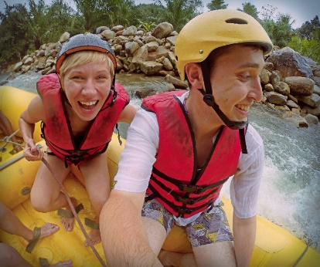
Options for maintaining interest of people on a tour include:
- Demonstrating personal passion – see below
- Tailoring information to the identified needs of the group – while the prepared commentary will/should have done this, it is also essential to do this with ‘issues arising’ throughout the tour such as:
- In response to questions
- When unexpected events and sights arise
- Using a prop kit – for activities and points of interest to add action, excitement, interest and flavour
- Always consider including props which can be given to, and used by, tour group participants as a way of involving and including them
- Using variety of approaches – this means ‘mixing it up when providing the commentary through the use of:
- Humour
- Statistics
- Questions
- Personal anecdotes and experiences
- Highlighting unexpected occurrences and including them in the commentary – and integrating them into the prepared commentary
- Interacting with tour group members – through personal exchanges and questions, sharing experiences and feelings: many complaints about a tour guide relate to their failure to mix with people, talk to/with them, and/or to demonstrate engagement with them
- Improvising the commentary – by incorporating topics of current interest to the group as identified through interaction with them
- This highlights the need to develop the ability to ‘think on your feet’ and adjust commentaries ‘on the fly’ to accommodate issues and preferences arising during the tour
- Striving to deliver excellent service at all times regardless of the problems or situations which present themselves – this involves:
- Turning negative circumstances into positive demonstrations of good service, wherever possible
- Asking people to do things, rather than telling them
- Smiling
- Treating tour group members as individuals and not as a ‘herd’
- Responding to requests where possible – and explaining why not when requests cannot be met
- Being polite and courteous
- Keeping promises made about the tour – such as the route, activities, inclusions and duration
- Providing relevant, accurate, timely and informative commentary and comments
- Keeping tour group members informed about the need to change planned/schedules activities – explaining the reasons why and (where possible) substituting a suitable alternative
- Demonstrating interest in tour group members – and their past, current and future experiences: where they have been, what they are doing now and where they are going and what they will be doing tomorrow/next week.
Accommodating needs and wishes of the group
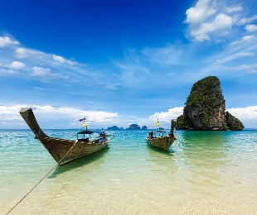
Considering the needs and wishes of participants may include allowing for:
- Quiet time – to allow people time to relax and savour a view or experience
- Free time – for tour group members to do their own thing: most tour group members will want some time to do what they want as opposed to doing what has been organised for them
- A time for people to chat – this may involve chatting amongst themselves, chatting with other people they meet on the tour (locals, shop keepers, other venue staff) or chatting with their Tour Guide
- Personal enjoyment of site – this is time enabling tour group members to enjoy the tour as best suits them, rather than as imposed by the tour schedule/itinerary
- Some people will prefer a passive orientation where they simply watch and listen while other will want a more active approach where they want to interact with people and activities
- Tour group members to have a rest – it is important to monitor the group regarding rest breaks and vital to understand the Tour Guide’s level of fitness does not dictate the requirements participants have to rest and recuperate
- Photo opportunities – always be alert to the need for people to take photographs to record their experience
- Many of these ‘photo opportunities’ are predictable and will remain the same for every tour but there are always unique moments which can arise where people wish to capture the moment
- Not being able to take photographs to suit individual need is a major source of complaint/dissatisfaction so be aware of the need to facilitate this. Be prepared, for example to:
- Allow extra time where everyone is taking photographs – if there is a need to save time to keep the tour on schedule try to save it somewhere else and not at the expense of restricting photos taken by the group
- Offer to take photographs for individuals – so they can be ‘in the photo’
- Be part of the photo – many people will want their Tour Guide to be part of their photograph
- Assist with the photo – by holding bags and other items
- ‘Up close and personal’ opportunities – tour group members expect many things of those who deliver tours and one of their main expectations is the presence of a Tour Guide will gain them access to things which are not available to people who are not on a tour
- This means they may request:
- A meeting with other staff/people at the site or venue
- Access to areas which are ‘off limits’ to other people/those who are not part of a tour
- Introductions to and/or more contact (effectively, more time) with people/other staff who are available – so they can talk more with the, ask them questions and/or watch them at work
- Special photo opportunities with (for example) animals, characters or unique sights

- Preferential treatment – this often relates to ‘small things’ but things which are important to the tour group members, such as:
- Being served first when meals are taken – as opposed to having to queue in line with the general public
- Being able to sit together for meals/refreshments – as opposed to having to take whatever seats are available
- Being given the ‘best’ seats’ when dining – seats with the best view, least disruption by pedestrian traffic
- Going to the front of lines/queues for rides, activities, displays, events etc
- Being loaded first onto transport so they can ‘sit with each other’ and get the ‘best seats’.
Counting participants
Counting participants throughout a tour is necessary to confirm all participants are still with the tour, or identify if someone is missing.
Counting of tour group participants should occur:
- Regularly – on an on-going basis: a time-based check may be used, say, every 10 – 15 minutes
- Before the tour leaves a point where participants have had to leave a vehicle – to verify all those who got off have got back on
- At certain points along a walking tour which are not ‘too far’ apart.
Techniques to assist with counting tour group members include
- Being certain of the starting number when the tour departed – as this is the reference point for the checks
- Updating records (manifests, passenger list) if a person notifies they are electing to quit the tour – tour group members usually have the right to leave a tour whenever they want to. The fact they have started the tour does not compel or obligate them to finish it
- Doing a physical head count of participants when the group arrives at a pre-determined head count point – this can involve:
- Physically counting people as they stand or sit
- Asking people to respond to a roll call using the manifest or passenger list as the basis
- Standing by the entry door of a vehicle and checking people as they re-board after a visiting/viewing experience – and ticking them off against the manifest
- Counting the number of seats filled on the bus when people have re-boarded – 45 participants should equate to 45 seats filled
- Asking tour group members a question “Is everyone here? Can you please check to see we are all here.” – this:
- Is an extremely effective approach
- Should be accompanied by a supplementary check.
Always record the count to demonstrate ‘due diligence’ – recording:
- Pax
- Time
- Location.
Implementing company policies when tour group members are unaccounted for

Company policies will commonly require action covering several of the following points:
- Halt the tour
- Conduct a re-count
- Identify number of people missing and names of same
- Notify management, head office, site supervisor, the control room or security staff – and advise of the situation identifying:
- Number/s missing
- Names of those missing
- Location
- Time missing person was identified
- Checks to-date to confirm absence of person/s
- Request other tour group members not to move/move away – this is to:
- Ensure a bad situation does not get worse by having more people wander off/go missing
- Allow access to them so they may be questioned
- Where necessary distribute drinks/refreshments – always try to make the sure people as comfortable as possible
- Conduct a brief search of the immediate area – call out to the missing person/use megaphone: do not involve other tour group members in the search
- Take charge of the situation – show confidence and demonstrate action to retrieve/resolve the situation
- Ask other participants if they know where missing person is – ask the group using PA and/or move among group asking people face-to-face
- A general question to the group can be effective “Does anyone know where David is?”, or “When was the last time anyone saw Cindy?”
- Confirm tour group numbers with group leader – this is really a double-check to make sure the initial count of the group was not incorrect
- It is always wise to verify a belief someone is missing is supported by others
- Confirm tour receipts with participants – to clarify those who are still with the tour – this, too, is a double-check to identify who is missing
- Do not allow other tour group members to go looking for the missing person/s
- This risks losing more members and may place them at risk. It is the job of the Tour Operator or leader to conduct and/or arrange search and recovery activities
- Prepare details of the missing person/s for hand-over to other staff and/or the authorities – this may include:
- Details from the manifest

- Photo ID
- CCTV footage of group arriving at main departure point – where applicable
- Details about the person obtained from the group leader and/or other tour group members (such as those who were sitting next to them; those who shared activities with them; people who were in the same boat/car when they went on a ride) – for example, medical needs/conditions.

Handling problems with tour group members
Tips include:
- Realise no problem will ever resolve itself – problems require action to fix/address them
- Take responsibility for taking action – it is part of the job to do so
- All identified issues must be addressed – never simply ignore a problem
- If appropriate/possible, look for ‘safety angle’ on which to focus the conversation to be had with those creating/causing a problem or issue
- People are more likely to listen and comply if it can be demonstrated they need to alter what they are doing because it is unsafe or poses a risk to others
- Treat people with respect – talk politely with them allow them their dignity
- Aim to make the other person feel special, not to feel victimised
- Talk with people who need to be spoken to away from others in order to respect their right not to be embarrassed or challenged in front of others
- Try to stay calm – when a need to intervene and say something to a participant arises
- ‘Act’ but do not ‘over-react’
- Avoid using a loud voice and try to speak so the conversation is private, and so the participant/s do not feel as if they are being reprimanded in front of the rest of the group and being made to look silly or ‘small’
- Phrase what is said so it is not a personal ‘attack’ on the other person – for example, instead of saying “You must not do that”, re-phrase the statement to “We prefer such action does not take place while here/on tour/in this location”
- Try phrasing statements asking people to modify their behaviour as ‘requests’ rather than ‘commands’.
- Give reasons why the request is being made
- There is big difference between ‘Stop doing that’ and “Could I please ask you not to do that because it scares the animals?”
- Look through the eyes of the tour group member and try to see things from their perspective
- For example, consider saying “I can see you are tired and I know we have walked quite a long way and it is hot, but I need you to know it is not acceptable for the safety of others for you to wander off on your own to have a rest”.

Dealing with problems between group members

When dealing with problems between tour group members always remember:
- It must be the Tour Guide who is in control of the tour – not the tour group members who are in control
- Never be afraid of asking for help or back-up from management, other staff or security – using two-way radio, or cell phone.
- Techniques to address problems between tour group members include:
- Ask the two parties to come to one side and talk – it is important everything said when addressing issues involving two parties is spoken in front of both parties so there can be no suspicion/question over what is said
- Where the tour is long one, attention should be paid to trying to resolve the root cause of the issue – where the tour is a short one, attention should focus on developing a solution to effectively address the problem until the tour has finished
- Ask the parties what the problem is – this allows insight and also allows the parties to get things off their chest
- Explain how their behaviour is adversely impacting the enjoyment of other tour group members
- Ask them to refrain from further action which disrupts the tour – and thank them for their cooperation
- Be prepared to suggest solution as to assist resolve the issue in the immediate short-term, such as:
- Re-seating people to different locations (for example, on the coach) so they are not near to each other, or are out of line-of-sight of the other person/party
- Asking parents to more closely supervise their children
- Re-grouping participants into different configurations so those having problems with another person/group in conflict are in different sub-groups when it comes to things such as viewing, activities, dining
- Monitoring the situation – and being prepared to:
- Repeat previous requests – it is naïve to believe people will modify their behaviour just because they have been asked once to do so
- Suggest alternative solutions to issues – and allow them to choose their preferred option
- Thank people for their cooperation.

On-departure/post-tour activities
The skills and knowledge which may need to be demonstrated at this stage can include any or all of the following:
Farewelling tour group members

At the end of the tour:
- Thank them for taking the tour
- Provide a farewell wish
- Express hope they enjoyed the tour/experience
- Encourage repeat tours
- Notify them of upcoming events and specials
- Handout promotional literature
- Invite them to tell others about the tour
- Distribute merchandise/product as required on departure of tour group members.
Capturing feedback
This may require:
- Distributing feedback forms
- Encouraging completion of Customer Comment Cards
- Mentioning online feedback options
- Talking to people about their tour and experience
- Seeking contributions for improvements and changes to the tour
- Asking if people have complaints
- Actively soliciting feedback and listening to and recording responses
- Thanking people for their input/feedback.
Thanking all relevant people
This may require thanking:
- Group leaders
- Transport drivers
- Catering staff
- Co-workers – who did the many things which combine to provide a memorable and effective tour, such as:
- Co-hosts/tour guides
- Safety officers and Security staff
- Monitors and observers – for rides and activities
- Park characters
- Section guides – specialists in certain areas who deliver information, activities and demonstrations in their particular area of expertise.
Completing end-of-tour activities
This may include:
- Signing off forms – these may relate to:
- Return of equipment
- Return of materials and props
- Return of keys
- Return of vehicles

- Completing required forms – which can include:
- Time sheets
- Incident reports
- Maintenance requests
- Manifests
- Tour report – detailing Name of tour, Dates, Times, Numbers and other information required by individual operators
- Handing in required items – such as:
- Forms identified immediately above
- Lost and Found items
- Customer comment cards
- Head count checks
- Cleaning up – this may relate to:
- Cleaning vehicles
- Tidying arrival and departure points
- Replenishing materials, handouts, promotional materials and merchandise distributed to (or taken by) tour group members
- Participating in de-briefing – with management, the marketing department and/or heads of sections to:
- Discuss events and the tour in general
- Identify lessons learned
- Identify opportunities for improvements, other tour types and/or potential tour group customers
- Reconciling cash and vouchers – for accounting, bookkeeping and business performance reasons
- Remitting payments received – for additional sales
- Forwarding feedback received.

3.2 Apply required legal, ethical and safety considerations to the conduct of tours

Introduction
All identified legal, ethical and safety considerations must be applied when conducting tours.
This section which must be read in conjunction with section 2.3 discusses implementation of these requirements.

Background to this requirement
It is important to understand/acknowledge:

- Consumers are becoming increasingly aware of their legal rights – so Tour Operators/tour leaders/guides need to be aware of their obligations to the client
- Legal terms and definitions are not always easy to interpret/understand – but there is an obligation to learn and interpret what they mean: importance is never an excuse
- Tour leaders/guides should know their legal rights/obligations
- There is a need to seek legal advice – from a legal professional, a recognised industry body/association or a relevant government agency
- Every Tourist Guide should be covered by public indemnity/liability (or similar) insurance
- All Tourist Guides should belong to a recognised Tour Guide Association – so they can obtain advice and assistance in this regard from industry specialists with relevant knowledge and experience
- A standard requirement for Tourist Guides is they hold a current and recognised First Aid certificate/qualification.

General application requirements
Obligations on Tour Operators and Tour Guides
Tour Operators and Tour Guides can be seen as breaking the law if they:
- Misrepresent tour activities, accommodation and other services and inclusions of a tour,
- Give negligent or inappropriate advice
- Provide unqualified or inappropriate staff or unsuitable suppliers to their tours
- Are negligent in their selection of supplier
- Do not provide for the care, wellbeing, comfort and safety of each individual on the tour.

They are obliged to:
- Provide the services as contracted – and outlined in brochure, contract or tender for the tour
- Ensure stated accommodation/services/sightseeing/attractions are included – as identified or promised
- Use/provide ‘expert guides’ – who know what they are doing and have suitable experience and expertise appropriate to the tour type
- Ensure all practices of guide and other staff are safe, ethical and professional
- Provide safe and reliable services and facilities – at all times.
Terms and conditions

For the employer/Tour Operator they are working for the Tour Guide must learn, understand and ensure they operate in compliance with all ‘Terms and Conditions’ that apply and have been provided to tour group members for their tour, in relation to :
- Deposit and balance conditions
- Cancellation and amendment condition charges
- Pricing policies – as linked to transport costs and/or currency fluctuations
- Exclusions/Inclusions
- Itinerary changes
- Personal and Property loss/injury/damage.
Potential claims
It is possible tour group members/clients will commence legal action if any of the following situations occur:
- Non-compliance with stated terms and conditions – as laid down by the Tour Operator in their promotional materials
- A tour leader/guide not adhering to the planned itinerary – as is their responsibility: that is, subject to unavoidable events (weather, closure of attractions, traffic accidents)
- Late provision of service – or late arrivals at destinations
- Inferior and/or cancelled service – when compared to itinerary/advertised tour/s
- Unfulfilled promises – of any sort
- Itinerary/accommodation changes – where inferior routes or destinations or accommodation are provided
- Loss/theft of property – whilst it is the responsibility of the tour company
- Accident, illness or death which occurs on tour.

Need to learn Tour Operator protocols
Not only must Tour Guides learn the SOPs for a Tour Operator but they must also:
- Study and implement all checking procedures as required by the business
- Learn, practice and be able to implement all contingency plans – to address situations where planned itinerary, routes, activities and similar cannot be followed
- Learn, practice and be able to implement all emergency plans – to address identified emergency events which might occur on tour.

Practical implementation requirements
Tour Guides must:
- Fulfil the Tour Operators contractual obligations – as stated in terms and conditions and any applicable contracts
- Ensure duty of care is discharged – to all consumers of the service/experience at all times
- Be familiar with the terms and conditions and content of the tour/s – in order this knowledge forms the basis of action taken
- Provide accurate, relevant, and current information – in relation to all aspects of the tour
- Meet the day-to-day activities of the tour – as per the contractual agreement between the employer, employee and the consumer
- Provide care and wellbeing, comfort and safety to each individual on the tour
- Conduct the tour in a professional manner
- Record all incidents and keep accurate records/documentation – of the tour
- Report and document any unusual occurrences
- Ensure all activities are performed under safe conditions and acknowledged practice.
Finally
Remember:
- A guide/tour leader is responsible for their group and any problems or incidents that arise while on tour – such as injury, loss of enjoyment, loss of property: all these may be seen as the responsibility of the guide
- A guide must take responsibility and decision make on behalf of the group – and always consider the contract of the tour and the best interests of the tourists when doing so
- Being a Tour Guide involves carrying and discharging many responsibilities – from the moment tour group members arrive until their final departure
- Being a Tour Guide requires:
- A ’cool head’ – in order to deal with the many problems, issues, challenges and issues which can arise in relation to tour and tour group members
- Good communication and people management skills – to provide information required, facilitate interactions, resolve problems, negotiate solutions, solve problems and deal with issues
- Loads of patience – because of the nature of constantly interacting and communicating with others.

3.3 Optimise respect for local culture

Introduction
All tours must be conducted to optimise respect for local culture.
This section introduces and defines ‘cultural host’, explains the need to respect local culture and presents ways this may be achieved.

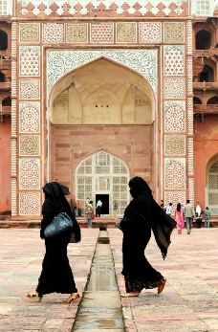
Cultural host
Being a cultural host is a major role of Tour Guide and is important because it:
- Helps visitors make a connection with the locals and the local culture and local people/communities
- Guards against and explains things which may cause ‘culture shock’ to some tourists
- Assists visitors assimilate into local surroundings and the local experience.
This is important so visitors are prevented from giving unintended offence to any place they visit, or person they meet.
This role is also emphasised in situations where the tour group members cannot speak the local language and the guide is needed to interpret or help with communication.

Need to respect local culture
It is important for Tour Guides to demonstrate respect for local culture for the following reasons:
- Meet expectations of tour group members
- Comply with promotional promises made about the tour
- Help minimise negative impacts of tour on local communities
- Maximise education of tourists regarding the country, area and/or communities
- Demonstrate the reverence in which aspects of the local area held by local people
- Generate enhanced local acceptance of tours by demonstrating appropriate respect for beliefs, customs and other important aspects of the people/community.

Ways to demonstrate respect for local culture
The following practices have proved effective in demonstrating respect for local culture:
- Abide by Tour Operator arrangements which have been made between them and local communities – in relation to the conduct of individual tours which may impact them
- Ask permission from locals – before taking certain actions:
- Never assume permission will be given
- Always consult before taking action
- Always use common sense – but err on the side of being deferential towards local communities
- Avoid mentioning certain aspects of the local culture – if asked to do so
- Be prepared to explain aspects of the culture – which are known to be generally misunderstood by others/tourists
- Provide anecdotes which explain and illustrate the local culture – as opposed to providing lectures about it
- Ensuring integrity of all guiding and interpretation activities – so accuracy and honesty is provided about local culture
- Leading by example – the actions of the Tour Guide are a critical model for those on the tour as they will follow/copy what the leader does
- Being sensitive to issues which may have significance for certain cultures – such as matters which may relate to:
- Gender
- Age
- Dress
- Modes of address
- Maintaining secrecy – about certain aspects which locals do not want disclosed or discussed with ‘outsiders’
- Support the local community – which may involve:
- Paying entry fees or other charges imposed by local communities
- Buying goods and services from locals
- Encouraging visitors to buy from the locals
- Using a guide from the local community to help conduct local tours of certain areas.
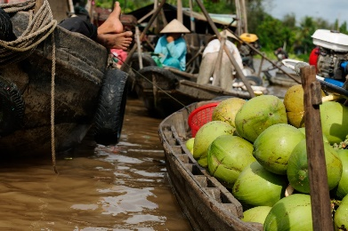

3.4 Minimise negative impact on the culture, people and environment

Introduction
Tour Guides must ensure all the tours they lead minimise the impact tours have on local culture, people and the environment.
This section discusses how to identify what is required in this regards and presents several standard procedures to enable compliance with what is needed.

Context
Key terms often used to describe and create awareness and action associated with relevant issues are:
- Ethical Tourism
- Sustainable Tourism
- Green Tourism
- Fair Trade in Tourism.
Websites
The websites below will provide more information and insight into issues inherent in the topics which are central to this consideration:
http://www2.unescobkk.org/elib/publications/IMPACT_LuangPrabang/impact.pdf - The effects of tourism on culture and the environment in Asia and the Pacific
http://www.toinitiative.org/fileadmin/docs/publications/sustainable_tourism.pdf - Sustainable Tourism: the Tour Operators’ Contribution
http://www.tourismconcern.org.uk/principles-and-definitions.html - TourismConcern: Action for ethical tourism
http://www.unesco.org/education/tlsf/mods/theme_c/mod16.html - Sustainable tourism

Identifying what is required
The standard and effective ways to determine what is required to minimise the negative impact of tours on local culture, people and the environment are to:
Talk to relevant people
This can require speaking with:
- Local elders and communities
- Other and more experienced Tour Guides
- The employer/Tour Operator
- Government officials who have involvement in and responsibility for local areas and tourism
- Local industry tour groups and associations – who will have been engaged in liaising with local stakeholders and with developing protocols for minimising impact.
Read relevant documentation

In many instances documentation has been developed to provide advice, guidelines of mandatory requirements to assist Tour Guides and Tourist Operators to minimise the impact of tours.
Documents may include those which are internal to the Tour Operator and imposed externally.
They may include:
- External documents
- Legislation – Acts and Regulations
- Local by-laws
- Codes of Practice
- Charters
- Agreements.
- Internal documents
- Policies
- SOPs
- Contracts
- Terms and conditions
- Commitments – made to compliance with relevant matters (see below).

Practical strategies

Practical procedures for minimising the negative impact of tours will usually also seek to optimise the positive impact of tours.
The following have emerged as effective actions:
- Be careful and sensitive in relation to ecological issues – do nothing to negatively impact the local ecology/environment:
- Limit local water use
- Never leave rubbish behind
- Take care to do nothing which erodes the land
- Be mindful of local persons, activities and preferences if asked by a local community – for example:
- Do not operate tours at times/on days identified by locals as being ‘restricted’ in some way (such as because of local religious or other beliefs, due to established local custom, as a result of the needs, wants and preferences of local people)
- Do not enter nominated areas – in certain locales
- Walk only on designated paths
- Do not go within a given distance of wildlife, activities, persons, buildings or other nominated events
- Ask tourists not to look at and/or intervene in nominated things – or initiate conversation with local people
- Advise and demonstrate to tourists important aspects of local manners – and what is considered normal and acceptable, as well as what is deemed to be rude and disrespectful
- Restrict numbers of tourists who enter an area – to reduce their immediate impact and to limit unintentional disturbance/interference with normal activities
- Ask tourists not to stare at locals
- Where appropriate, tell visitors to ask for permission before taking photographs – or ban taking of cameras/cell phones into certain areas
- Control visitations – by:
- Setting limits for:
- Maximum numbers on a tour
- Number of visits/tours to an area/destination per day, week or other period
- Developing and offering alternatives – to tours to sensitive areas
- Providing effective management of tours and tour group members
- Commit to compliance – this means:
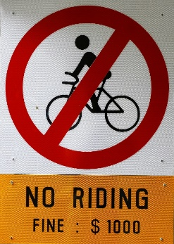
- Making public statements the tour and the Tour Guide and Tour Operator:
- Is committed to nominated Codes and Agreements
- Is committed to observing and implementing all relevant legislation
- Advising tour groups:
- Of the limitations/restrictions imposed on tours by Agreements, Codes and legislation
- Scheduled activities and the planned itinerary are subject to change where the Tour Guide believes they will negatively impact the local area
- Anyone identified as breaching requirements in this regard will be asked to modify their behaviour and/or leave the tour.
- Participate in planning – as Tour Guides it is important to:
- Take part in discussions about principles and practices for responsible and sustainable tour actions
- Provide feedback and input to the planning process based on personal experiences and observations
- Be prepared to implement and trial draft policies and procedures.

Work Projects
It is a requirement of this Unit you complete Work Projects as advised by your Trainer. You must submit documentation, suitable evidence or other relevant proof of completion of the project to your Trainer by the agreed date.
3.1 Provide evidence you have worked as a Tour Guide in a real-life or simulated context providing proof you have:
- Planed a tour of the local area lasting a minimum of two hours including production of an itinerary for the tour
- Prepared a scripted commentary for the tour
- Conducted necessary pre-departure checks and activities prior to commencing the tour as appropriate to a professional, commercial fee-for-service Tour Operator
- Led/conducted the tour demonstrating the interpretive approach to guiding
- Managed the tour effectively addressing interpersonal issues, matters arising, special needs and demonstrating appropriate interpersonal, communication and group management skills
- Finished the tour demonstrating a range of standard industry ‘end-of-tour’ activities designed to capture feedback and leave a positive impression which will encourage repeat and referral business.

Summary

Provide guiding services
When providing guiding services:
- Identify and undertake required pre-departure checks and activities
- Determine and discharge all required on-tour activities and obligations
- Establish and complete all identified/required end-of-tour activities
- Prepare and deliver commentaries as required
- Manage the tour group and resolve issues arising
- Implement contingency and emergency plans as/when necessary
- Ensure compliance with tour promises, safety requirements, ethical obligations and ethical standards
- Observe respect for local communities and culture/s
- Demonstrate action designed to optimise visitor engagement and experiences while minimising negative impacts of the tour
- Optimise positive impacts of the tour
- Respect everyone associated with the tour
- Apply effective interpersonal, communication and group leadership skills.

Element 4: Communicate with industry personnel

4.1 Communicate with tourism industry operators

Introduction

Not only is there a need for Tour Guides to communicate with tour group members but there is also a need for them to communicate with a selection of tourism industry operators.
This section identifies who these operators may be, presents possible topics for discussion, and discusses basic protocols for such communication.

Tourism industry operators
Individual circumstance
The exact nature of the cross-section of industry operators and personnel a Tour Guide might need to communicate with will depend on:
- The type of tours being conducted – daily half-day city walking tours will involve different stakeholders to 10-day camping tours of six different countries
- Associations and relations between the Tour Operator and others – under contracts, strategic partnerships, joint ventures, partnerships
- Contracted obligations – imposed as a consequence of legally binding contracts requiring (for example) attendance at meetings and/or provisions of feedback or reports
- Commitment by the business to Codes and similar other voluntary accords – which require participation in nominated events, seminars, meetings, conventions, conferences and similar.
Examples of tourism industry operators with whom communication may be required
There can be a need for Tour Guides to communicate with:
- Carriers – who can include:
- Coach companies
- Cruise operators
- Airlines
- Other transport operators
- Destinations:
- Businesses
- Built attractions
- Natural attractions
- Boards of Management and/or owners and/or staff
- Third party providers:

- Accommodation providers
- Caterers and food and beverage outlets
- Tour-based operators::
- Other Tour Operators – local, national and international
- Inbound Tour Operators
- Wholesale Tour Operators.

Possible topics for communication
Topics for discussion when communicating with tourism industry operators can be expected to address:
- Feedback from tourists about:
- Satisfaction levels
- Suggestions for change
- Special requests
- Best/worst aspects of their experience
- Regular/common complaints and compliments
- Results of customer/market research conducted by the business in relation to a range of issues such as:
- What they liked /disliked
- Reasons for using the services of the business
- Needs, wants and preferences
- Recommendations for improvements and initiatives – in relation to:
- Inclusions
- Pricing
- Destinations
- Itineraries
- Scheduling
- Carriers
- Social, cultural and business requirements and contexts - including practical implementation of tour delivery in relation to issues such as:
- Verbal and body language
- Cultural customs and mores
- Ethical conduct
- Sustainability
- Identification of operational problems – and presentation of possible solutions to same based on personal experience and known operational parameters.

Communication basics
When communicating with tourism industry operators the following points should be observed:
- Honour commitments – make an effort to:
- Attend required meetings
- Contribute as required or as promised
- Learn what is required and meet those obligations
- Use industry terminology – but clarify any terms, phrases, acronyms or abbreviations with the potential to confuse
- Seek to:
- Provide information
- Source information
- Achieve mutual understanding
- Reach agreement on issues and guiding activities and protocols
- Consult in an open manner
- Be careful – take care to:
- Differentiate personal opinion from employer point of view
- Separate fact from opinion
- Never commit the employer to anything without their express permission
- Ask employer to approve statements or comments to be made on behalf of the organisation.


4.2 Communicate with colleagues

Introduction
As well as communicating with tourism industry operators there is also an ongoing need for Tour Guides to communicate with their colleagues.
This section identifies who these colleagues may be and presents a range of communication opportunities and methods.

Colleagues to communicate with
In most cases Tour Guides will have some need to communicate with the following colleagues
- Other guides – within the same Tour Operator organisation who may be:
- Those who conduct similar/the same type of tours
- Those who conduct other tour types with different durations, itineraries, destinations, inclusions and tour groups
- Support staff – who can include any employees (but often predominantly office staff and counter service staff) within the host organisation with responsibility for things such as:
- Market research
- Customer contact
- Bookings and sales
- Administration which underpins the work of Tour Guides
- Staff who arrange and organise activities, products, services and provisions/resources for Tour Guides
- Drivers – of vehicles such as buses, vans, cars, utility vehicles, four-wheel drives and other specialist vehicles which may be:

- Owned
- Leased
- Hired or rented by the employer
- Management of the business – which may include:
- Owners
- Managers
- Supervisors.

Communication opportunities
Opportunities for communication with other colleagues include:
- Daily briefing sessions
- The ‘Communication Book’ or similar used by many employers
- Regular staff meetings
- Chance meetings with others
- Use of internal communication forms and reports which need to be completed before, during and at the end of tours- and after designated activities such as various checks and inspections
- Taking advantage of ‘open door’ policy implemented by management.
It is vital Tour Guides create/make opportunities to communicate when they have something to say/something they want to share or communicate.

Communication methods
Methods to communicate with colleagues are likely to include:
- Making presentations at meetings – involving a range/combination of:
- Speech, discussion and talking
- Handouts
- Slide presentations
- Guest Speakers
- Demonstrations
- Talking to people:
- Face-to-face

- On the telephone
- One-on-one
- In groups
- Using written communication options:
- Providing handouts of information to be conveyed
- Supplying hard copy suggestions/recommendations
- Putting complaints and issues in writing
- Completing internal forms and reports
- Sending memoranda
- Using electronic communication options – such as:
- Email
- Text messaging.

Work Projects
It is a requirement of this Unit you complete Work Projects as advised by your Trainer. You must submit documentation, suitable evidence or other relevant proof of completion of the project to your Trainer by the agreed date.
4.1 Provide samples of written communication on topics of your own choice which a Tour Guide may have with:
- Management/owners of a tour operating business
- A carrier used by the Tour Operator
- One internal colleagues at the business other than a Tour Guide
- Another Tour Guide employed at the same business.

Summary

Communicate with industry personnel
When communicating with industry personnel:
- Identify those with whom communication is required
- Communicate on a regular basis and ‘as required’
- Communicate using a variety of techniques and opportunities/options
- Be clear in what is communicated
- Differentiate fact from opinion
- Never speak on behalf of employer without their express permission
- Be prepared to share insight, experience and feedback received from tour group members
- Contribute to the greater good and for the benefit of everyone
- Make an effort to communicate – be proactive.

Presentation of written work

Introduction
It is important for students to present carefully prepared written work. Written presentation in industry must be professional in appearance and accurate in content. If students develop good writing skills whilst studying, they are able to easily transfer those skills to the workplace.

Style

Students should write in a style that is simple and concise. Short sentences and paragraphs are easier to read and understand. It helps to write a plan and at least one draft of the written work so that the final product will be well organised. The points presented will then follow a logical sequence and be relevant. Students should frequently refer to the question asked, to keep ‘on track’. Teachers recognise and are critical of work that does not answer the question, or is ‘padded’ with irrelevant material. In summary, remember to:
- Plan ahead
- Be clear and concise
- Answer the question
- Proofread the final draft.

Presenting Written Work
Types of written work
Students may be asked to write:
- Short and long reports
- Essays
- Records of interviews
- Questionnaires
- Business letters
- Resumes.
Format
All written work should be presented on A4 paper, single-sided with a left-hand margin. If work is word-processed, one-and-a-half or double spacing should be used. Handwritten work must be legible and should also be well spaced to allow for ease of reading. New paragraphs should not be indented but should be separated by a space. Pages must be numbered. If headings are also to be numbered, students should use a logical and sequential system of numbering.
Cover Sheet
All written work should be submitted with a cover sheet stapled to the front that contains:
- The student’s name and student number
- The name of the class/unit
- The due date of the work
- The title of the work
- The teacher’s name
- A signed declaration that the work does not involve plagiarism.
Keeping a Copy
Students must keep a copy of the written work in case it is lost. This rarely happens but it can be disastrous if a copy has not been kept.
Inclusive language
This means language that includes every section of the population. For instance, if a student were to write ‘A nurse is responsible for the patients in her care at all times’ it would be implying that all nurses are female and would be excluding male nurses.
Examples of appropriate language are shown on the right:
Mankind | Humankind
Barman/maid | Bar attendant
Host/hostess | Host
Waiter/waitress | Waiter or waiting staff

Recommended reading
Note: all Recommended Reading is sourced from ‘Trove: National Library of Australia’ at http://trove.nla.gov.au/.
Cole, Jo & Adelaide Institute of TAFE & South Australia. Dept. of Further Education, Employment, Science and Technology 2000, Coordinating and operating a tour, Adelaide Institute of TAFE, Adelaide, S. Australia
Collins, Verité Reily 2000, Becoming a tour guide: principles of guiding and site interpretation, Continuum, London
Knudson, Douglas M & Cable, Ted T., (author.) & Beck, Larry, 1953-, (author.) 2003, Interpretation of cultural and natural resources, Second edition, State College, Pennsylvania Venture Publishing
Kotler, Philip & Bowen, John T & Makens, James C 2015, Marketing for hospitality and tourism, Sixth edition, Boston Pearson
Mancini, Marc 2001, Conducting tours, 3rd ed, Delmar/Thomson Learning, Albany
Mitchell, G. E 2005, How to start a tour guiding business: a "how-to" manual for the thousands of people who want to discover the world of travel as a career, 3rd ed, GEM Group, Charleston, S.C
Pastorelli, John 2003, Enriching the experience: an interpretive approach to tour guiding, Pearson Education Australia, Frenchs Forest, N.S.W

Trainee evaluation sheet

Work as a tour guide
The following statements are about the competency you have just completed.
Please tick the appropriate box | Agree | Don’t Know | Do Not Agree | Does Not Apply
There was too much in this competency to cover without rushing.
Most of the competency seemed relevant to me.
The competency was at the right level for me.
I got enough help from my trainer.
The amount of activities was sufficient.
The competency allowed me to use my own initiative.
My training was well-organised.
My trainer had time to answer my questions.
I understood how I was going to be assessed.
I was given enough time to practice.
My trainer feedback was useful.
Enough equipment was available and it worked well.
The activities were too hard for me.

The best things about this unit were:

The worst things about this unit were:

The things you should change in this unit are:

Trainee self-assessment checklist
As an indicator to your Trainer/Assessor of your readiness for assessment in this unit please complete the following and hand to your Trainer/Assessor.

Work as a tour guide
 |  | Yes | No*
Element 1: Describe the context for the delivery of guiding services
1.1 | Identify the roles, functions and responsibilities of a tour guide
1.2 | List and differentiate between types of tour guides
1.3 | Identify and differentiate between the groups a tour guide may lead
1.4 | Describe the interpretive approach to tour guiding
1.5 | Identify tour types
1.6 | List the characteristics of a tour guide
1.7 | Describe tour guiding principles
Element 2: Develop guiding skills and knowledge
2.1 | Identify guide information sources and contacts
2.2 | Acquire and up-date industry skills and knowledge
2.3 | Identify legal, ethical and safety requirements that apply to provision of guiding services
Element 3: Provide guiding services
3.1 | Demonstrate the skills and knowledge necessary to guide tours
3.2 | Apply required legal, ethical and safety considerations to the conduct of tours
3.3 | Optimise respect for local culture
3.4 | Minimise negative impact on the culture, people and environment
Element 4: Communicate with industry personnel
4.1 | Communicate with tourism industry operators
4.2 | Communicate with colleagues

Statement by Trainee:
I believe I am ready to be assessed on the following as indicated above:
Signed: _____________________________ | Date: ____________

Note:
For all boxes where a No* is ticked, please provide details of the extra steps or work you need to do to become ready for assessment.









